

Wireless Network Broadband Router 11M
WL-025

Full Manual

Table of Contents
Requirements 4
Introduction 4
WL-025 Features 4
Internet Access Features 4
Advanced Internet Functions 4
Wireless Features 5
LAN Features 5
Configuration & Management 5
Security Features 6
Setting up the Router 7
Physical installation 7
Top LEDs 9
Rear Panel 10
PC Setup 11
Set up TCP/IP 11
Using DHCP 11
Windows 98/ME 11
Windows 2000/XP 11
Windows NT 13
Macintosh Clients 14
Linux Clients 14
Wireless Adapter 14
Internet access 15
Windows 98/ME/2000 15
Windows XP 15
Accessing AOL 15
Manual configuration – Internet access 16
Your country/ISP is not listed 19
Cable Internet 19
xDSL Internet 23
Home Screen 28
LAN Screen 29
DHCP 29
Wireless screen 31
WEP Screen 33
Password Screen 34
Operation and Status 35
Operation 35
Status Screen 35
Connection Status - PPPoE 37
Connection Status - PPTP 39
Connection Status - L2TP 40
Connection Details - Fixed/Dynamic IP Address 42
Advanced Features 43
Overview 43
Advanced Internet Screen 44
Communication Applications 44
Special Applications 45
Special Applications Screen 45
Using a Special Application 46
Multi-DMZ 46
URL Filter 47
URL Filter Screen 47
Access Control 49
Overview 49
Access Control Screen 49
Group Members Screen 51
Default Schedule Screen 51
Services Screen 52
Access Control Log 54
Remote Management 55
Virtual Servers 56
IP Address seen by Internet Users 56
Virtual Servers Screen 56
Defining your own Virtual Servers 58
Connecting to the Virtual Servers 59
Dynamic DNS (Domain Name Server) 60
Dynamic DNS Screen 60
Upgrade Firmware 62
Config File 63
PC Database 64
PC Database Screen 64
PC Database (Admin) 65
Network Diagnostics 68
Options 69
Security 71
Logs 73
MAC Address 75
MAC Address Screen 75
Printer Port 76
Routing 77
Overview 77
Routing Screen 77
Configuring Other Routers on your LAN 79
Static Routing - Example 80
Appendix A Troubleshooting 81
Overview 81
General Problems 81
Internet Access 82
Printing 82
Wireless Access 85
Appendix B Specifications 87
Wireless Network Broadband Router 87
Wireless Interface 87
FCC Statement 88
FCC Radiation Exposure Statement 88
CE Marking Warning 88

Requirements
- Cable modem or DSL/ADSL modem.
- Standard 10/100BaseT (UTP) network cables with RJ45 connectors.
- PCs that make use of the TCP/IP network protocol.

Introduction
Congratulations on the purchase of your new WL-025 Broadband Router. The WL-025 is a multi-function device providing the following services:
- Shared Broadband Internet Access for all LAN users.
- 4-Port Switching Hub for 10BaseT or 100BaseT connections.

WL-025 Features
The WL-025 incorporates many advanced features, carefully designed to provide sophisticated functions while being easy to use.

Internet Access Features
- Shared Internet Access. All users on the LAN or WLAN can access the Internet through the WL-025, using only a single external IP Address. The local (invalid) IP Addresses are hidden from external sources. This process is called NAT (Network Address Translation).
- DSL & Cable Modem Support. The WL-025 has a 10/100BaseT Ethernet port for connecting a DSL or Cable Modem. All popular DSL and Cable Modems are supported. SingTel RAS and Big Pond (Australia) login support is also included.
- Supports all Connection Methods. The Internet (WAN port) connection supports PPPoE (PPP over Ethernet), PPTP (Peer-to-Peer Tunneling Protocol), L2TP (Level 2 Tunneling Protocol), SingTel RAS and Telstra Big Pond (Australia), as well as “Direct Connection” type services.
- Fixed or Dynamic IP Address. On the Internet (WAN port) connection, the WL-025 supports both Dynamic IP Address (IP Address is allocated on connection) and Fixed IP Address.

Advanced Internet Functions
- Communication Applications. Support for Internet communication applications, such as interactive Games, Telephony, and Conferencing applications, which are often difficult to use when behind a Firewall, is included.
- Special Internet Applications. Applications which use non-standard connections or port numbers are normally blocked by the Firewall. The ability to define and allow such applications is provided, to enable such applications to be used normally.
- Virtual Servers. This feature allows Internet users to access Internet servers on your LAN. The required setup is quick and easy.
- DMZ. One (1) PC on your local LAN can be configured to allow unrestricted 2-way communication with Servers or individual users on the Internet. This provides the ability to run programs which are incompatible with Firewalls.
- URL Filter. Use the URL Filter to block access to undesirable Web sites by LAN users.
- Internet Access Log. See which Internet connections have been made.
- Access Control. Using the Access Control feature, you can assign LAN users to different groups, and determine which Internet services are available to each group.
- VPN Pass through Support. PCs with VPN (Virtual Private Networking) software using PPTP, L2TP and IPSec are transparently supported - no configuration is required.

Wireless Features
- Standards Compliant. The WL-025 complies with the IEEE802.11b (DSSS) specifications for Wireless LANs.
- WEP support. Support for WEP (Wired Equivalent Privacy) is included. Key sizes of 64 Bit and 128 Bit are supported.
- Access Control. The Access Control feature can ensure that only trusted Wireless Stations can access your LAN.
- Simple Configuration. If the default settings are unsuitable, they can be changed quickly and easily.

LAN Features
- 4-Port Switching Hub. The WL-025 incorporates a 4-port 10/100BaseT switching hub, making it easy to create or extend your LAN.
- DHCP Server Support. Dynamic Host Configuration Protocol provides a dynamic IP address to PCs and other devices upon request. The WL-025 can act as a DHCP Server for devices on your local LAN and WLAN.
- Multi Segment LAN Support. LANs containing one or more segments are supported, via the WL-025's RIP (Routing Information Protocol) support and built-in static routing table.

Configuration & Management
- Easy Setup. Use your WEB browser from anywhere on the LAN for configuration.
- Configuration File Upload/Download. Save (download) the configuration data from the WL-025 to your PC, and restore (upload) a previously-saved configuration file to the WL-025.
- Remote Management. The WL-025 can be managed from any PC on your LAN. And, if the Internet connection exists, it can also (optionally) be configured via the Internet.
- UPnP Support. UPnP (Universal Plug and Play) allows automatic discovery and configuration of the WL-025. UPnP is by supported by Windows ME, XP, or later.

Security Features
- Password - protected Configuration. Optional password protection is provided to prevent unauthorized users from modifying the configuration data and settings.
- NAT Protection. An intrinsic side effect of NAT (Network Address Translation) technology is that by allowing all LAN users to share a single IP address, the location and even the existence of each PC is hidden. From the external viewpoint, there is no network, only a single device - the WL-025.
- Stateful Inspection Firewall. All incoming data packets are monitored and all incoming server requests are filtered, thus protecting your network from malicious attacks from external sources.
- Protection against DoS attacks. DoS (Denial of Service) attacks can flood your Internet connection with invalid packets and connection requests, using so much bandwidth and so many resources that Internet access becomes unavailable. The WL-025 incorporates protection against DoS attacks.

Setting up the Router

Physical installation
- For the installation of the Broadband router it is assumed that you have at least one PC with a working broadband Internet connection. It is also assumed that the modem is configured in accordance with the requirements of your ISP and of the modem manufacturer. If not, first consult the manual of your ISP.
- Before you begin, check that power is not connected to either the broadband router or the cable modem/DSL modem. Leave your cable modem/DSL modem plugged in (telephone line or cable input).
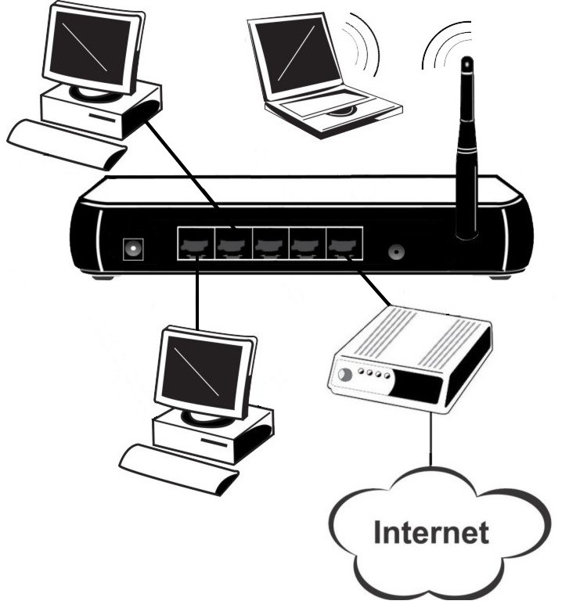

Installation - WL-025

- Connect the LAN cables: For the WL-025, use standard LAN cables to connect the PCs to the LAN ports (hub) on the broadband Router.
- Connect your cable modem/DSL modem to the WAN-port on the broadband Router. Use the cable supplied with your cable modem/DSL modem. If no cable was supplied with your modem, use a standard network cable.
- Your wireless PC’s need some configuration which is explained later on in this manual.
- Switch on the cable modem/DSL modem.
- Connect the power supply adapter to the broadband Router. Use only the adapter supplied with the router.
- Check the LEDs
- The Power LED should be ON.
- The Status LED should flash, then turn Off. If it stays on, there is a hardware error.
- For each LAN (PC) connection, the LAN Link/Act LED should be ON (provided the PC is also ON.)
- The WAN LED should be ON.
- The WLAN LED should be ON

Top LEDs
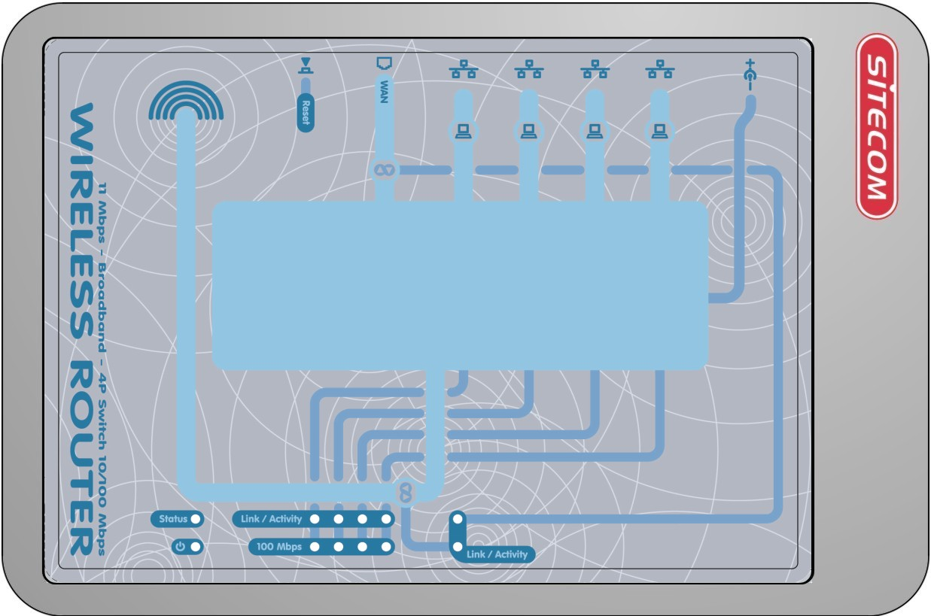
Status  (Yellow) | Power | LAN | WLAN LED  (Link/Activity) | WAN
On - Error condition.  Off - Normal operation.  Blinking - This LED blinks during start up. | On - Power on.  Off –  No Power. | Link/Act  On - Corresponding LAN (hub) port is active.  Off - No active connection on the corresponding LAN (hub) port.  Flashing - Data is being transmitted or received via the corresponding LAN (hub) port.  100  On - Corresponding LAN (hub) port is using 100BaseT.  Off - Corresponding LAN (hub) port connection is using 10BaseT, or no active connection. | On - Wireless connection is available, but Idle (no traffic).  Off - Error - No Wireless connection available.  Flashing - Data is being transmitted or received via the Wireless access point. This includes "network traffic" as well as user data. | On –  Connection to the modem attached to the WAN (Internet) port is established.  Flashing –  Data is being transmitted or received via the WAN port. For each port, there are 2 LEDs

Rear Panel
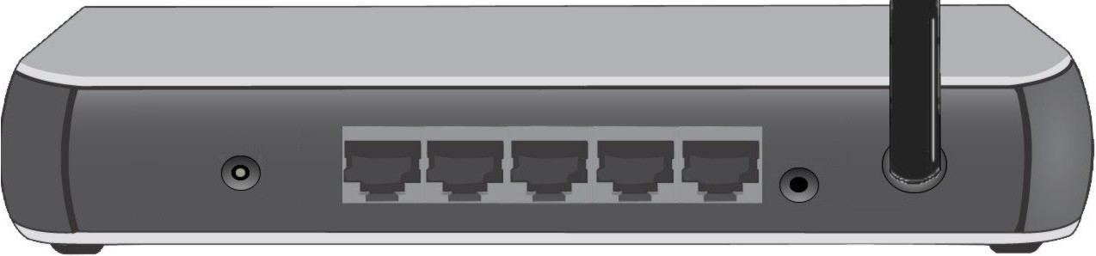
Power port | 10/100BaseT  LAN connections | WAN port  (10/100BaseT) | Reset Button
Connect the supplied power adapter here. | Use standard LAN cables (RJ45 connectors) to connect your PCs to these ports.  Note:  Any LAN port on the WL-025 will automatically function as an "Uplink" port when required. Just connect any port to a normal port on the other hub, using a standard LAN cable. | Connect the DSL or Cable Modem here. If your modem came with a cable, use the supplied cable. Otherwise, use a standard LAN cable. | This button has two (2) functions:  Reboot. When pressed and released, the WL-025 will reboot (restart).  Diagnostic print-out. If held down for 3 seconds, a diagnostic print-out will be sent to the attached printer. Ensure the printer is ready before doing this.  Clear All Data. This button can also be used to clear ALL data and restore ALL settings to the factory default values.  To Clear All Data and restore the factory default values:  Power Off.  Hold the Reset Button down while you Power On.  Keep holding the Reset Button for a few seconds, until the RED Status LED on the front panel has flashed TWICE.  Release the Reset Button. The WL-025 is now using the factory default values.

PC Setup

Set up TCP/IP
If you are using a Fixed (specified) IP address, the following changes are required:
- The Gateway must be set to the IP address of the WL-025
- The DNS should be set to the address provided by your ISP.

Using DHCP
To use DHCP, select the radio button Obtain an IP Address automatically. This is the default Windows setting. Using this is recommended. By default, the WL-025 will act as a DHCP Server.

Windows 98/ME
Right click the Network Neighbourhood icon on the desktop and click Properties. The following window will be displayed:
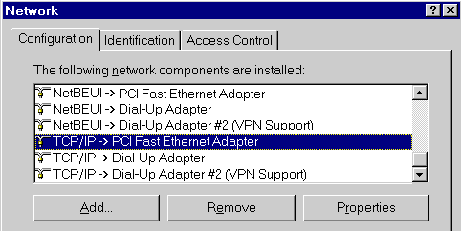

Windows 2000/XP
Right click the My Network Places icon on the desktop and click Properties. The following window will be displayed:

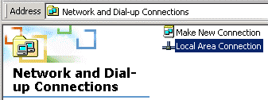

Right click the Local Area Connection of the correct network card, and then choose Properties.
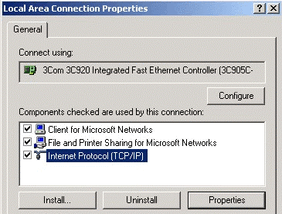

If the list that appears on screen does not include a line, such as the one that has been selected above ("TCP/IP -> network card"), then follow the steps indicated below for adding this line:
- Click on the button "Add"
- Double-click on "Protocol"
- Select "Microsoft" and thereafter "TCP/IP"
- Click on "OK"
- Wait a few seconds, so that TCP/IP can be added. Thereafter, click on "OK" to leave the network properties screen. Restart your PC.

Select the line “TCP/IP -> Network card” as shown above. Click on the button Properties to obtain a window similar to the following:

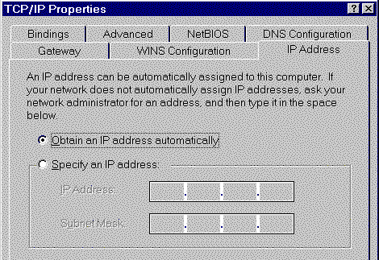

Check whether the setting "Obtain an IP address automatically" has been selected, as is illustrated above. The DHCP server in the broadband router will now assign an IP address to the PC.

Windows NT
Select Control Panel - Network, and, on the Protocols tab, select the TCP/IP protocol, as shown below.
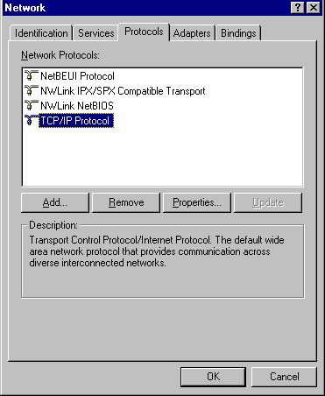
Click the Properties button to see a screen like the one below.
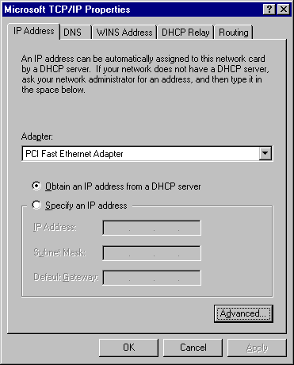

Select the network card for your LAN.
Select the appropriate radio button - Obtain an IP address from a DHCP Server
Restart your PC, even if you have not made any changes.

Macintosh Clients
From your Macintosh, you can access the Internet via the WL-025. The procedure is as follows.
- Open the TCP/IP Control Panel.
- Select Ethernet from the Connect via pop-up menu.
- Select Using DHCP Server from the Configure pop-up menu. The DHCP Client ID field can be left blank.
- Close the TCP/IP panel, saving your settings.
Note:
If using manually assigned IP addresses instead of DHCP, the required changes are:
- Set the Router Address field to the WL-025's IP Address.
- Ensure your DNS settings are correct.

Linux Clients
To access the Internet via the WL-025, it is only necessary to set the WL-025 as the "Gateway".
Ensure you are logged in as "root" before attempting any changes.
Fixed IP Address
By default, most Unix installations use a fixed IP Address. If you wish to continue using a fixed IP Address, make the following changes to your configuration.
- Set your "Default Gateway" to the IP Address of the WL-025.
- Ensure your DNS (Name server) settings are correct.
To act as a DHCP Client (recommended)
The procedure below may vary according to your version of Linux and X -windows shell.
- Start your X Windows client.
- Select Control Panel - Network
- Select the "Interface" entry for your Network card. Normally, this will be called "eth0".
- Click the Edit button, set the "protocol" to "DHCP", and save this data.
- To apply your changes
- Use the "Deactivate" and "Activate" buttons, if available.
- OR, restart your system.

Wireless Adapter
If your network adapter is a wireless adapter, besides above TCP/IP settings you also have to set the ESSID to ‘Sitecom’ and the mode to ‘Infrastructure’ in order to make a connection with the Wireless Broadband Router

Internet access

Windows 98/ME/2000
- In the Taskbar, click on the Start button and select Settings - Control Panel - Internet options.
- Select the tab page Connections and click on the button Settings.
- Select "I want to configure my Internet connection manually" or "I want to make a connection via a LAN network" and click on "Next >".
- Select "I want to connect via a LAN network" and click on "Next >".
- Check carefully that all of the checkboxes in the screen Internet configuration for a LAN have not been checked.
- Continue with the steps in the wizard, until the task is completed.
- The configuration is now completed.

Windows XP
- In the Taskbar, click on the Start button and select - Settings – Control Panel - Internet options.
- Select the tab Connections and click the Setup… button.
- When the New Connection Wizard starts, click on Next.
- Select Connect to internet and click on Next.
- Select Set up my connection manually and click on Next.
- Select Connect using a broadband connection that is always on and click on Next.
- Click on Finish to close the Wizard.
- In the Taskbar, click on the Start button and select - Settings – Control Panel - Internet options.
- Select the Connections tab and click on the LAN Settings button.
- Check carefully that none of the boxes in the Local Area Network (LAN) Settings window are checked.
- The configuration is now completed.

Accessing AOL
To access AOL (America On Line) through the WL-025, the AOL for Windows software must be configured to use TCP/IP network access, rather than a dial-up connection. The configuration process is as follows:
- Start the AOL for Windows communication software. Ensure that it is Version 2.5, 3.0 or later. This procedure will not work with earlier versions.
- Click the Setup button.
- Select Create Location, and change the location name from "New Locality" to "WL-025".
- Click Edit Location. Select TCP/IP for the Network field. (Leave the Phone Number blank.)
- Click Save, then OK.
Configuration is now complete.
- Before clicking "Sign On", always ensure that you are using the "WL-025" location.

Manual configuration – Internet access
- Make TCP/IP settings on your PC, as described in the foregoing section.
Do not forget to restart your PC after you have finished.
- Using UPnP
If your Windows system supports UPnP, an icon for the WL-025 will appear in the system tray, notifying you that a new network device has been found, and offering to create a new desktop shortcut to the newly-discovered device.
- Unless you intend to change the IP Address of the WL-025, you can accept the desktop shortcut.
- Whether you accept the desktop shortcut or not, you can always find UPnP devices in My Network Places.
Double click the icon for the WL-025 (either on the Desktop, or in My Network Places) to start the configuration. Proceed with step 4.
- Start your web browser. In the Address field, enter the following: 192.168.0.1

If you can't connect
If the WL-025 does not respond, check the following:
- The WL-025 is properly installed, LAN connection is OK, and it is powered ON. You can test the connection by using the "Ping" command:
- Open the MS-DOS window or command prompt window.
- Enter the command:
ping 192.168.0.1
If no response is received, either the connection is not working, or your PC's IP address is not compatible with the WL-025's IP Address. (See next item.)
- If your PC is using a fixed IP Address, its IP Address must be within the range 192.168.0.2 to 192.168.0.254 to be compatible with the WL-025's default IP Address of 192.168.0.1. Also, the Network Mask must be set to 255.255.255.0. See Chapter 4 - PC Configuration for details on checking your PC's TCP/IP settings.
- Ensure that your PC and the WL-025 are on the same network segment. (If you don't have a router, this must be the case.)

- The start up window will now be displayed. Click on Setup.
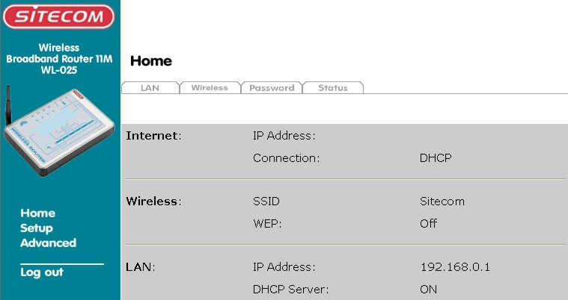
- The Set up wizard will now be displayed; check that the modem is connected and click on Next.
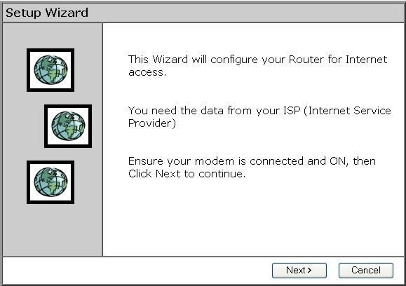
- Select your country from the Country list. If your Country isn’t listed, please see the next Chapter “Your Country/ISP is not listed”
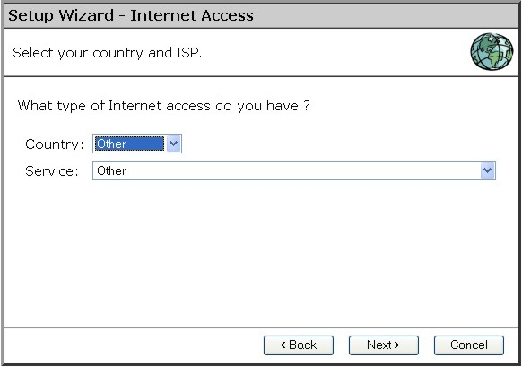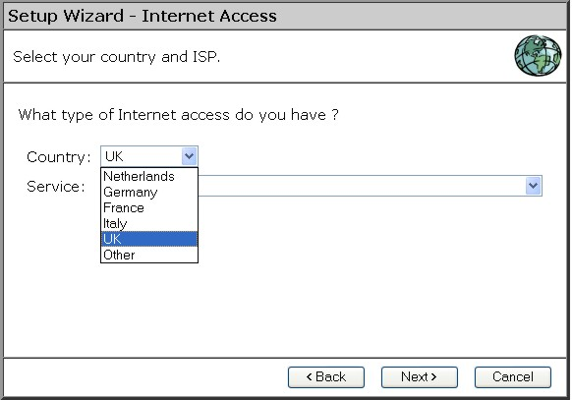
- From Service, select your internet provider. Click Next.
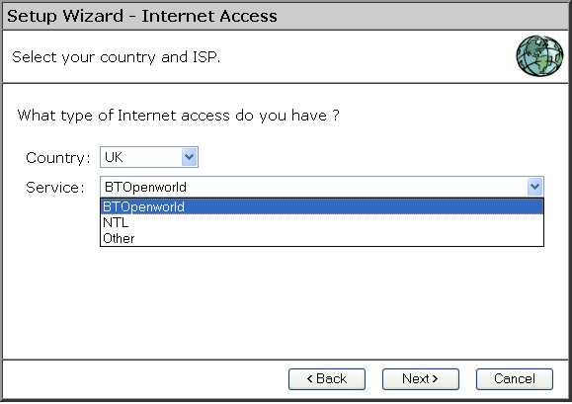
- Depending on the chosen provider, you may need to enter your user name and password and MAC address or hostname in the following window. Then click on Next.
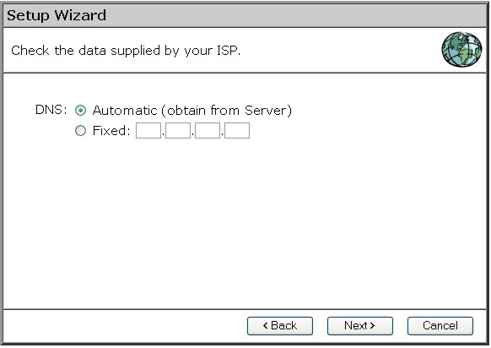
- Click finish to complete the configuration. Click on Close. If Test Internet Connection is checked, the router will test the connection after you have clicked on finish. Wait until this test has been completed before you click on close.
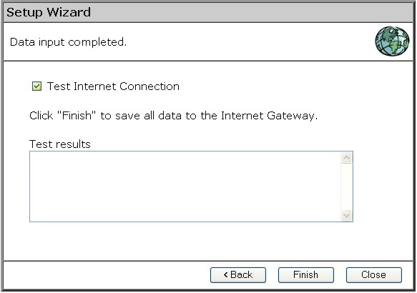

The configuration is now completed.

Your country/ISP is not listed
Select the type of your Internet connection, (for instance cable or ADSL) and then click on Next.
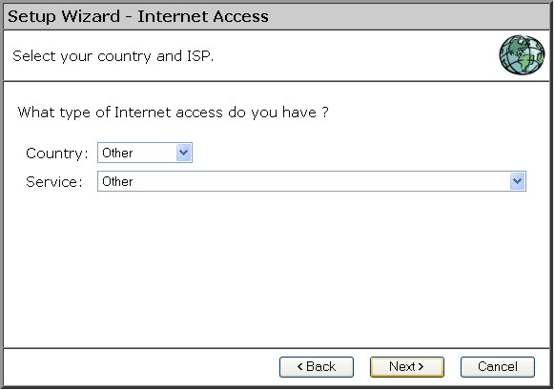

Cable Internet

- Fill in the Hostname and the Domain name, if you received this from your Internet service provider.
For some providers it will be necessary to fill in the MAC address of the network card the Modem was attachet to originally.
If you received an username and password from your ISP, then choose PPPoE
If you received an Server address from your provider besides an username and password, then choose L2TP (Currently L2TP is only used by a Dutch provider)
If you didn’t receive a username and password, then choose None.

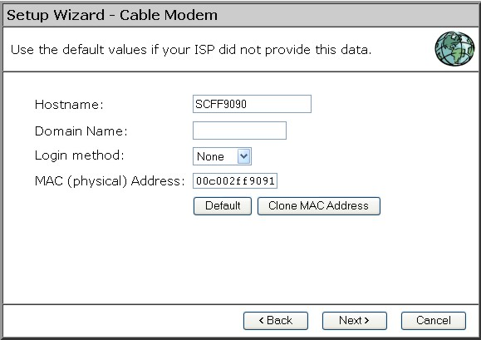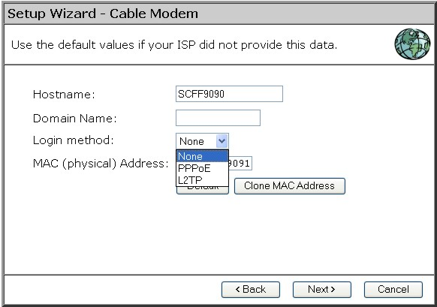

- PPPoE
Fill in your Username and your password.
Choose the Connect Behavior.
"Automatic connect/Disconnect" causes the router to connect as soon as an application is started which require an internet connection (i.e. MSN, ICQ, Windows update, etc.)
"Manual Connect/Disconnect" causes the router to connect only when the user clicks ‘connect’ in the ‘Connection details’ window.
“Keep Alive” cuases the router to maintain the connection at all time.
The “Auto-disconnect Time-out periode” is the amount of time after which the router disconnects from internet.
Then click Next.
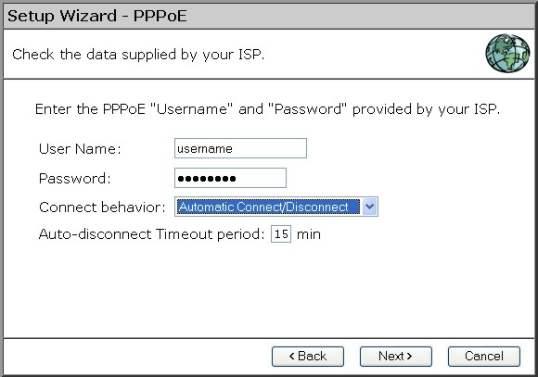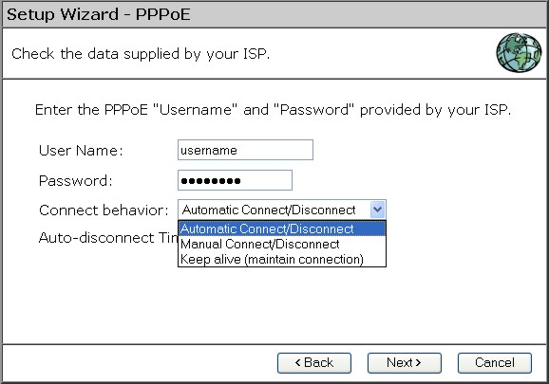
If your provider has assigned you a fixed IP address, you input this in the field Specified IP Address and also fill in your DNS IP address. If you have a dynamic IP address, select the option IP address is assigned automatically. The click Next.
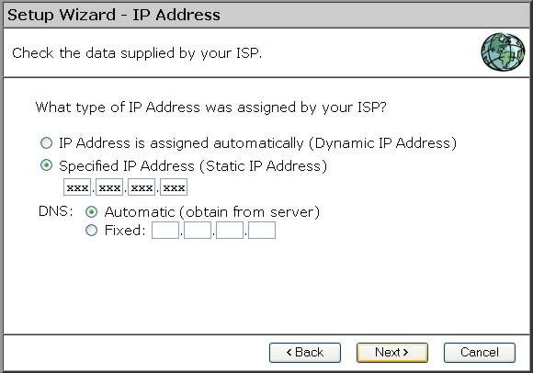
Click finish to complete the configuration. Click on Close. If Test Internet Connection is checked, the router will test the connection after you have clicked on finish. Wait until this test has been completed before you click on close.
The configuration is now completed.
- L2TP
Fill in the L2TP server IP address or Domain Name
Fill in your Username and your password.
Choose the Connect Behavior.
"Automatic connect/Disconnect" causes the router to connect as soon as an application is started which require an internet connection (i.e. MSN, ICQ, Windows update, etc.)
"Manual Connect/Disconnect" causes the router to connect only when the user clicks ‘connect’ in the ‘Connection details’ window.
“Keep Alive” causes the router to maintain the connection at all time.
The “Auto-disconnect Time-out periode” is the amount of time after which the router disconnects from internet.
Then click Next.
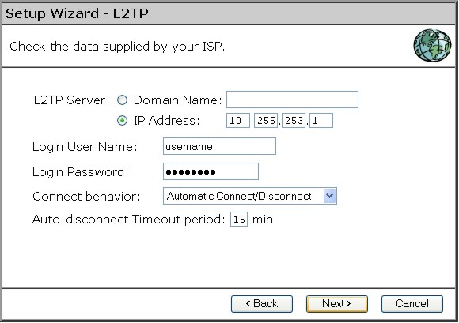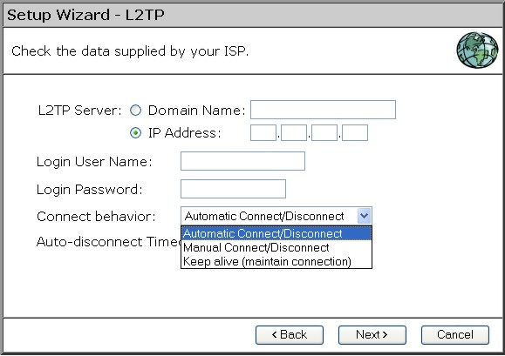
If your provider has assigned you a fixed IP address, you input this in the field Specified IP Address and also fill in your DNS IP address. If you have a dynamic IP address, select the option IP address is assigned automatically. The click Next.
Click finish to complete the configuration. Click on Close. If Test Internet Connection is checked, the router will test the connection after you have clicked on finish. Wait until this test has been completed before you click on close.
The configuration is now completed
- NONE
If your provider has assigned you a fixed IP address, you input this in the field Specified IP Address and also fill in your DNS IP address. If you have a dynamic IP address, select the option IP address is assigned automatically. The click Next.

Click finish to complete the configuration. Click on Close. If Test Internet Connection is checked, the router will test the connection after you have clicked on finish. Wait until this test has been completed before you click on close.

The configuration is now completed

xDSL Internet

If you received an username and password from your ISP, then choose PPPoE
If you received an Server address from your provider besides an username and password, then choose PPTP or L2TP. Please check with your ISP which protocol you need.(Currently L2TP is only used by a Dutch provider)
If you didn’t receive a username and password, then choose None.

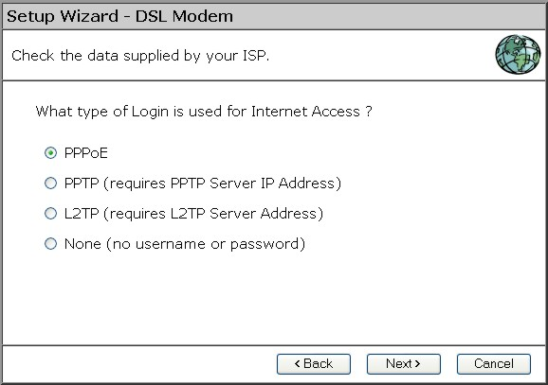

- PPPoE
Fill in your Username and your password.
Choose the Connect Behavior.
"Automatic connect/Disconnect" causes the router to connect as soon as an application is started which require an internet connection (i.e. MSN, ICQ, Windows update, etc.)
"Manual Connect/Disconnect" causes the router to connect only when the user clicks ‘connect’ in the ‘Connection details’ window.
“Keep Alive” cuases the router to maintain the connection at all time.
The “Auto-disconnect Time-out periode” is the amount of time after which the router disconnects from internet.
Then click Next.
If your provider has assigned you a fixed IP address, you input this in the field Specified IP Address and also fill in your DNS IP address. If you have a dynamic IP address, select the option IP address is assigned automatically. The click Next.
Click finish to complete the configuration. Click on Close. If Test Internet Connection is checked, the router will test the connection after you have clicked on finish. Wait until this test has been completed before you click on close.
The configuration is now completed.
- PPTP
Fill in the PPTP server IP address or Domain Name
Fill in your Username and your password.
Choose the Connect Behavior.
"Automatic connect/Disconnect" causes the router to connect as soon as an application is started which require an internet connection (i.e. MSN, ICQ, Windows update, etc.)
"Manual Connect/Disconnect" causes the router to connect only when the user clicks ‘connect’ in the ‘Connection details’ window.
“Keep Alive” causes the router to maintain the connection at all time.
The “Auto-disconnect Time-out periode” is the amount of time after which the router disconnects from internet.
Then click Next.
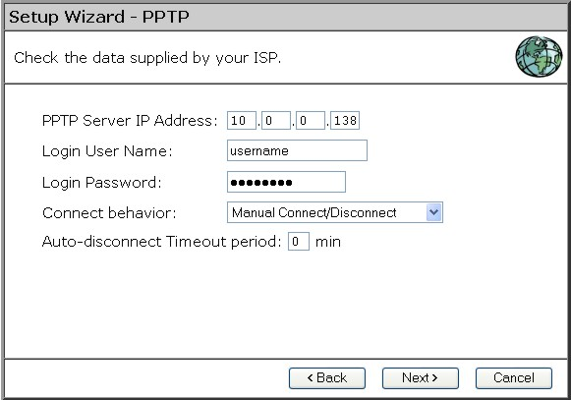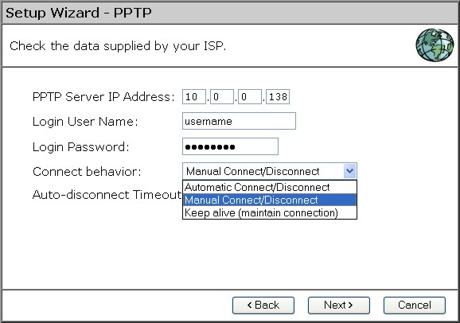
If your provider has assigned you a fixed IP address, you input this in the field Specified IP Address and also fill in your DNS IP address. If you have a dynamic IP address, select the option IP address is assigned automatically. The click Next.
Click finish to complete the configuration. Click on Close. If Test Internet Connection is checked, the router will test the connection after you have clicked on finish. Wait until this test has been completed before you click on close.
The configuration is now completed
- L2TP
Fill in the L2TP server IP address or Domain Name
Fill in your Username and your password.
Choose the Connect Behavior.
"Automatic connect/Disconnect" causes the router to connect as soon as an application is started which require an internet connection (i.e. MSN, ICQ, Windows update, etc.)
"Manual Connect/Disconnect" causes the router to connect only when the user clicks ‘connect’ in the ‘Connection details’ window.
“Keep Alive” causes the router to maintain the connection at all time.
The “Auto-disconnect Time-out periode” is the amount of time after which the router disconnects from internet.
Then click Next.
If your provider has assigned you a fixed IP address, you input this in the field Specified IP Address and also fill in your DNS IP address. If you have a dynamic IP address, select the option IP address is assigned automatically. The click Next.
Click finish to complete the configuration. Click on Close. If Test Internet Connection is checked, the router will test the connection after you have clicked on finish. Wait until this test has been completed before you click on close.
The configuration is now completed
- NONE
If your provider has assigned you a fixed IP address, you input this in the field Specified IP Address and also fill in your DNS IP address. If you have a dynamic IP address, select the option IP address is assigned automatically. The click Next.

Click finish to complete the configuration. Click on Close. If Test Internet Connection is checked, the router will test the connection after you have clicked on finish. Wait until this test has been completed before you click on close.

The configuration is now completed

Home Screen
After finishing the Setup Wizard, you will see the Home screen. When you connect in future, you will see this screen when you connect. An example screen is shown below.

Navigation & Data Input
- Use the menu bar on the left of the screen, and the "Back" button on your Browser, for navigation.
- Changing to another screen without clicking "Save" does NOT save any changes you may have made. You must "Save" before changing screens or your data will be ignored.

 | On each screen, clicking the "Help" button will display help for that screen.  From any help screen, you can access the list of all help files (help index).

LAN Screen
Click LAN tab In the HOME menu to reach the LAN screen An example screen is shown below.
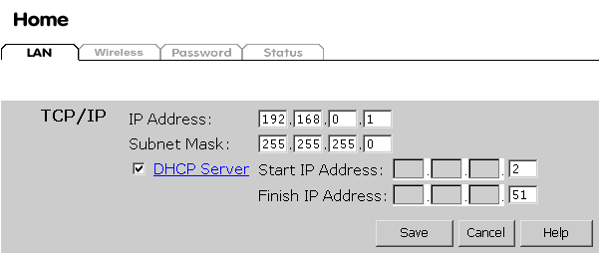

Data - LAN Screen
TCP/IP
IP Address | IP address for the WL-025, as seen from the local LAN. Use the default value unless the address is already in use or your LAN is using a different IP address range. In the latter case, enter an unused IP Address from within the range used by your LAN.
Subnet Mask | The default value 255.255.255.0 is standard for small (class "C") networks. For other networks, use the Subnet Mask for the LAN segment to which the WL-025 is attached (the same value as the PCs on that LAN segment).
DHCP Server | - If Enabled, the WL-025 will allocate IP Addresses to PCs (DHCP clients) on your LAN when they start up. The default (and recommended) value is Enabled.  - If you are already using a DHCP Server, this setting must be Disabled, and the existing DHCP server must be re-configured to treat the WL-025 as the default Gateway. See the following section for further details.  - The Start IP Address and Finish IP Address fields set the values used by the DHCP server when allocating IP Addresses to DHCP clients. This range also determines the number of DHCP clients supported.  See the following section for further details on using DHCP.
Buttons
Save | Save the data on screen.
Cancel | The "Cancel" button will discard any data you have entered and reload the file from the WL-025.

DHCP

What DHCP Does
A DHCP (Dynamic Host Configuration Protocol) Server allocates a valid IP address to a DHCP Client (PC or device) upon request.
- The client request is made when the client device starts up (boots).
- The DHCP Server provides the Gateway and DNS addresses to the client, as well as allocating an IP Address.
- The WL-025 can act as a DHCP server.
- Windows 95/98/ME and other non-Server versions of Windows will act as a DHCP client. This is the default Windows setting for the TCP/IP network protocol. However, Windows uses the term Obtain an IP Address automatically instead of "DHCP Client".
- You must NOT have two (2) or more DHCP Servers on the same LAN segment. (If your LAN does not have other Routers, this means there must only be one (1) DHCP Server on your LAN.)

Using the WL-025's DHCP Server
This is the default setting. The DHCP Server settings are on the LAN screen. On this screen, you can:
- Enable or Disable the WL-025's DHCP Server function.
- Set the range of IP Addresses allocated to PCs by the DHCP Server function.

You can assign Fixed IP Addresses to some devices while using DHCP, provided that the Fixed IP Addresses are NOT within the range used by the DHCP Server.

Using another DHCP Server
You can only use one (1) DHCP Server per LAN segment. If you wish to use another DHCP Server, rather than the WL-025's, the following procedure is required.
- Disable the DHCP Server feature in the WL-025. This setting is on the LAN screen.
- Configure the DHCP Server to provide the WL-025's IP Address as the Default Gateway.

Wireless screen
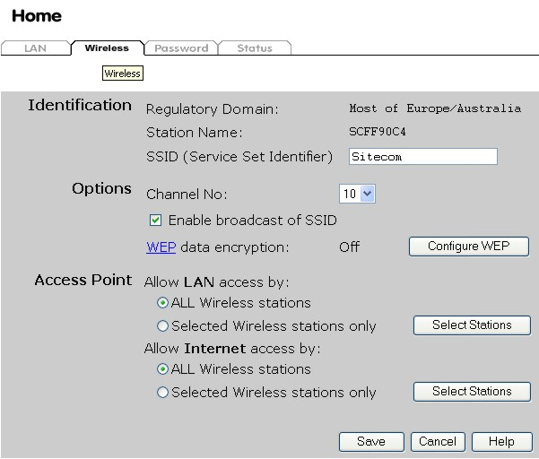

Data - Wireless Screen
Identification
Regulatory  Domain | It is illegal to use this device in any location outside of the regulatory domain.
Station name | This is the same as the "Device Name" for the Wireless Router.  On your PC, some Wireless status screens may display this name as the name of the Access Point in use.
SSID  (ESSID) | - If using an ESS (Extended Service Set, with multiple access points) this ID is called an ESSID (Extended Service Set Identifier).  - To communicate, all Wireless stations should use the same SSID/ESSID.
Options
Channel No. | - Select the Channel you wish to use on your Wireless LAN.  - If you experience interference (shown by lost connections and/or slow data transfers) you may need to experiment with different channels to see which is the best.  - If using multiple Access Points, adjacent Access Points should use different Channels to reduce interference.
Enable ESSID Broadcast | When enabled the Wireless Homestation can be found by any wireless adapter via the ‘site survey’ option. When unchecked, the accesspoint is hidden. This is an extra security feature
WEP data  encryption | - WEP (Wired Equivalent Privacy) status will display "Enabled" or "Disabled", depending on whether WEP is being used. If used, data is Encrypted before being transmitted, making communication more secure.  - Click the "Configure WEP" button to access the WEP sub-screen, and view or change the WEP settings.
Access Point
Allow LAN  access by … | - All Wireless Stations - All wireless stations can use the access point to access your LAN.  - Selected Wireless stations only - Only selected wireless stations access your LAN. To select the required wireless stations, click the "Select Stations" button.
Allow Internet  access by … | - All Wireless Stations - All wireless stations can use the access point to access the Internet.  - Selected Wireless stations only - Only selected wireless stations use the access point to access the Internet. To select the required wireless stations, click the "Select Stations" button.
Buttons
Configure WEP | Click this button to view the WEP sub-screen. See the following section for more details.
Select Stations | Click this button to select the required PCs.
Save | Save the data on screen.
Cancel | The "Cancel" button will discard any data you have entered since the last "Save" operation.

WEP Screen
This screen is accessed by clicking the "Configure WEP" button on the Wireless screen.
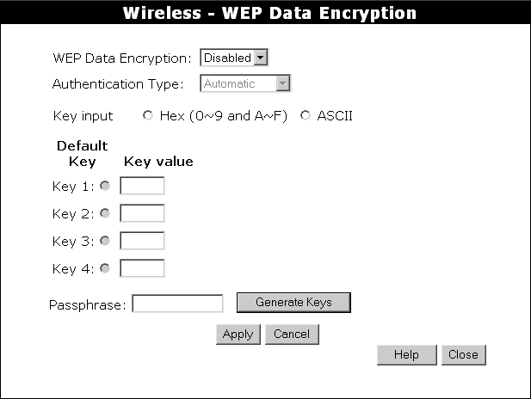

Data - WEP Screen
WEP Data Encryption
WEP Data Encryption | Select the option to match other Wireless Stations:  - Disabled - data is NOT encrypted before being transmitted.  - 64 Bit - data is encrypted, using the default key, before being transmitted. You must enter at least the default key. For 64 Bit Encryption, the key size is 5 chars (ASCII) or 10 chars in HEX (0~9 and A~F).  - 128 Bit - data is encrypted, using the default key, before being transmitted. You must enter at least the default key. For 128 Bit Encryption, the key size is 13 chars (ASCII) or 26 chars in HEX (0~9 and A~F).  - 256 Bit - data is encrypted, using the default key, before being transmitted. You must enter at least the default key. For 256 Bit Encryption, the key size is 29 chars (ASCII) or 58 chars in HEX (0~9 and A~F).
Authentication Type | Normally, this should be left at the default value of "Automatic". If changed to "Open System" or "Shared Key", ensure that your Wireless Stations use the same setting.
WEP Keys | - Key Input - Select "Hex" or "ASCII" depending on your input method. (All keys are converted to Hex, ASCII input is only for convenience.)  - Default Key - select the key you wish to be the default. Transmitted data is ALWAYS encrypted using the Default Key; the other Keys are for decryption only.  - Key Value - Enter the key value you wish to use. Other stations must have the same key.
Passphrase | If desired, you can generate a key from a phrase, instead of entering the key value directly. Enter the desired phrase, and click the "Generate Keys" button.

Password Screen
The password screen allows you to assign a password to the WL-025.
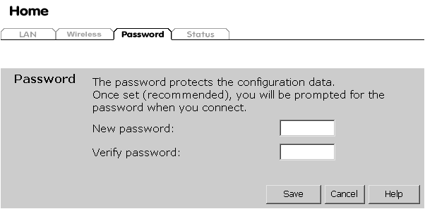
Once you have assigned a password to the WL-025 (on the Password screen above) you will be prompted for the password when you connect, as shown below. (If no password has been set, this dialog will not appear.)
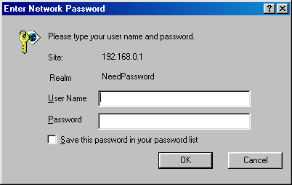

- Leave the "User Name" blank.
- Enter the password for the WL-025, as set on the Password screen above.

Operation and Status

Operation
Once both the WL-025 and the PCs are configured, operation is automatic.
However, there are some situations where additional Internet configuration may be required:
- If using Internet-based Communication Applications, it may be necessary to specify which PC receives an incoming connection. Refer to chapter Advanced Features for further details.
- Applications which use non-standard connections or port numbers may be blocked by the WL-025's built-in firewall. You can define such applications as Special Applications to allow them to function normally. Refer to chapter Advanced Features for further details.
- Some non-standard applications may require use of the DMZ feature. Refer to chapter Advanced Features for further details.

Status Screen
Use the Status tab on the Home menu to view this screen.
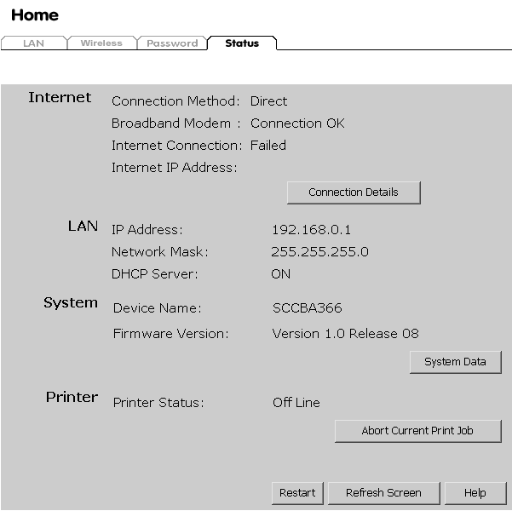

Data - Status Screen
Internet
Connection Method | This indicates the current connection method, as set in the Setup Wizard.
Broadband Modem | This shows the connection status of the modem.
Internet Connection | Current connection status:  - Active  - Idle  - Unknown  - Failed  If there is an error, you can click the "Connection Details" button to find out more information.
Internet IP Address | This IP Address is allocated by the ISP (Internet Service Provider).
"Connection Details"  Button | Click this button to open a sub-window and view a detailed description of the current connection. Depending on the type of connection, a "log" may also be available.
LAN
IP Address | The IP Address of the WL-025.
Network Mask | The Network Mask (Subnet Mask) for the IP Address above.
DHCP Server | This shows the status of the DHCP Server function - either "Enabled" or "Disabled".  For additional information about the PCs on your LAN, and the IP addresses allocated to them, use the PC Database option on the Advanced menu.
System
Device Name | This displays the current name of the WL-025.
Firmware Version | The current version of the firmware installed in the WL-025.
"System Data"  Button | Clicking this button will open a Window which lists all system details and settings.
Printer
Printer Status | This indicates the current status of the printer. Possible values are:  - Idle  - Printing  - Off-line  - Out of paper
"Abort Current Print Job" Button | Click this button to terminate the current print job. This button should be used if the current print job is not printing correctly.
Buttons
Connection Details | View the details of the current Internet connection. The sub-screen displayed will depend on the connection method used. See the following sections for details of each sub-screen.
System Data | Display all system information in a sub-window.
Restart | Clicking this button will restart (reboot) the WL-025. All existing connections though the WL-025 will be terminated, but will usually re-connect automatically.
Refresh Screen | Update the data displayed on screen.

Connection Status - PPPoE
If using PPPoE (PPP over Ethernet), a screen like the following example will be displayed when the "Connection Details" button is clicked.
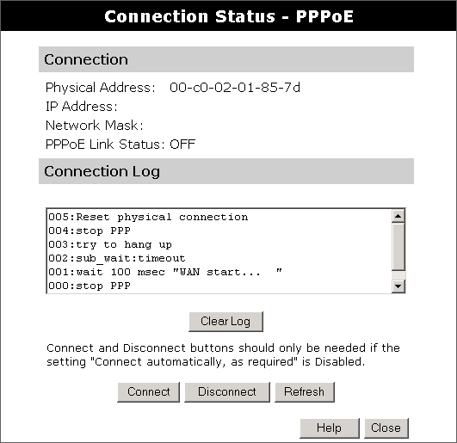

Data - PPPoE Screen
Connection
Physical Address | The hardware address of this device, as seen by remote devices on the Internet. (This is different to the hardware address seen by devices on the local LAN.)
IP Address | The IP Address of this device, as seen by Internet users. This address is allocated by your ISP (Internet Service Provider).
Network Mask | The Network Mask associated with the IP Address above.
PPPoE Link Status | This indicates whether or not the connection is currently established.  - If the connection does not exist, the "Connect" button can be used to establish a connection.  - If the connection currently exists, the "Disconnect" button can be used to break the connection.
Connection Log
Connection Log | - The Connection Log shows status messages relating to the existing connection.  - The most common messages are listed in the table below.  - The "Clear Log" button will restart the Log, while the Refresh button will update the messages shown on screen.
Buttons
Connect | If not connected, establish a connection to your ISP.
Disconnect | If connected to your ISP, hang up the connection.
Clear Log | Delete all data currently in the Log. This will make it easier to read new messages.
Refresh | Update the data on screen.

Connection Status - PPTP
If using PPTP (Peer-to-Peer Tunneling Protocol), a screen like the following example will be displayed when the "Connection Details" button is clicked.
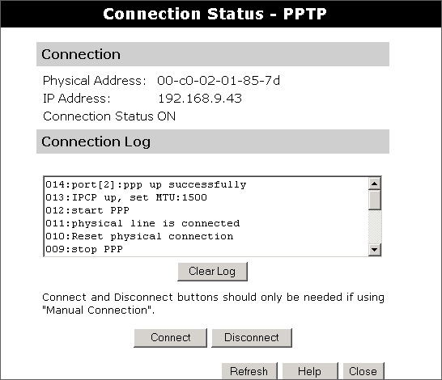

Data - PPTP Screen
Connection
Physical Address | The hardware address of this device, as seen by remote devices on the Internet. (This is different to the hardware address seen by devices on the local LAN.)
IP Address | The IP Address of this device, as seen by Internet users. This address is allocated by your ISP (Internet Service Provider).
PPTP Status | This indicates whether or not the connection is currently established.  - If the connection does not exist, the "Connect" button can be used to establish a connection.  - If the connection currently exists, the "Disconnect" button can be used to break the connection.
Connection Log
Connection Log | - The Connection Log shows status messages relating to the existing connection.  - The "Clear Log" button will restart the Log, while the Refresh button will update the messages shown on screen.
Buttons
Connect | If not connected, establish a connection to your ISP.
Disconnect | If connected to your ISP, hang up the connection.
Clear Log | Delete all data currently in the Log. This will make it easier to read new messages.
Refresh | Update the data on screen.

Connection Status - L2TP
If using L2TP, a screen like the following example will be displayed when the "Connection Details" button is clicked.
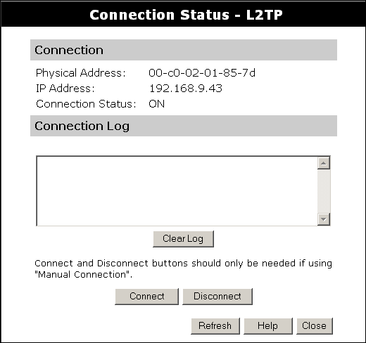
Figure 1: L2TP Status Screen

Data - L2TP Screen
Connection
Physical Address | The hardware address of this device, as seen by remote devices on the Internet. (This is different to the hardware address seen by devices on the local LAN.)
IP Address | The IP Address of this device, as seen by Internet users. This address is allocated by your ISP (Internet Service Provider).
Connection Status | This indicates whether or not the connection is currently established.  - If the connection does not exist, the "Connect" button can be used to establish a connection.  - If the connection currently exists, the "Disconnect" button can be used to break the connection.
Connection Log
Connection Log | - The Connection Log shows status messages relating to the existing connection.  - The "Clear Log" button will restart the Log, while the Refresh button will update the messages shown on screen.
Buttons
Connect | If not connected, establish a connection to your ISP.
Disconnect | If connected to your ISP, hang up the connection.
Clear Log | Delete all data currently in the Log. This will make it easier to read new messages.
Refresh | Update the data on screen.

Connection Log Messages
Message | Description
Connect on Demand | Connection attempt has been triggered by the "Connect automatically, as required" setting.
Manual connection | Connection attempt started by the "Connect" button.
Reset physical connection | Preparing line for connection attempt.
Connecting to remote server | Attempting to connect to the ISP's server.
Remote Server located | ISP's Server has responded to connection attempt.
Start PPP | Attempting to login to ISP's Server and establish a PPP connection.
PPP up successfully | Able to login to ISP's Server and establish a PPP connection.
Idle time-out reached | The connection has been idle for the time period specified in the "Idle Time-out" field. The connection will now be terminated.
Disconnecting | The current connection is being terminated, due to either the "Idle Time-out" above, or "Disconnect" button being clicked.
Error: Remote Server not found | ISP's Server did not respond. This could be a Server problem, or a problem with the link to the Server.
Error: PPP Connection failed | Unable to establish a PPP connection with the ISP's Server. This could be a login problem (name or password) or a Server problem.
Error: Connection to Server lost | The existing connection has been lost. This could be caused by a power failure, a link failure, or Server failure.
Error: Invalid or unknown packet type | The data received from the ISP's Server could not be processed. This could be caused by data corruption (from a bad link), or the Server using a protocol which is not supported by this device.

Connection Details - Fixed/Dynamic IP Address
If your access method is "Direct" (no login), a screen like the following example will be displayed when the "Connection Details" button is clicked.
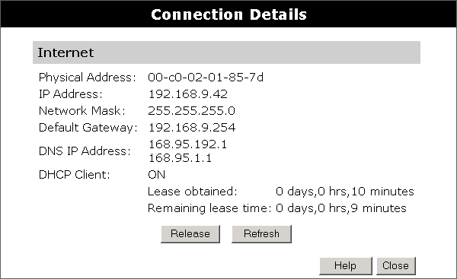

Data - Fixed/Dynamic IP address Screen
Internet
Physical Address | The hardware address of this device, as seen by remote devices on the Internet. (This is different to the hardware address seen by devices on the local LAN.)
IP Address | The IP Address of this device, as seen by Internet users. This address is allocated by your ISP (Internet Service Provider).
Network Mask | The Network Mask associated with the IP Address above.
Default Gateway | The IP Address of the remote Gateway or Router associated with the IP Address above.
DNS IP Address | The IP Address of the Domain Name Server which is currently used.
DHCP Client | This will show "Enabled" or "Disabled", depending on whether or not this device is functioning as a DHCP client.  If "Enabled" the "Remaining lease time" field indicates when the IP Address allocated by the DHCP Server will expire. The lease is automatically renewed on expiry; use the "Renew" button if you wish to manually renew the lease immediately.
Buttons
Release/Renew  Button will display EITHER  "Release"  OR  "Renew" | This button is only useful if the IP address shown above is allocated automatically on connection. (Dynamic IP address). If you have a Fixed (Static) IP address, this button has no effect.  - If the ISP's DHCP Server has NOT allocated an IP Address for the WL-025, this button will say "Renew". Clicking the "Renew" button will attempt to re-establish the connection and obtain an IP Address from the ISP's DHCP Server.  - If an IP Address has been allocated to the WL-025 (by the ISP's DHCP Server), this button will say "Release". Clicking the "Release" button will break the connection and release the IP Address.
Refresh | Update the data shown on screen.

Advanced Features

Overview
The following advanced features are provided.
- Advanced Internet
- Communication Applications
- Special Applications
- Multi-DMZ
- URL Filter
- Access Control
- Remote Management
- Virtual Servers
- Dynamic DNS
- Upgrade Firmware
- Config File
- PC Database
- Network Diagnostics
- Options
- Security
- Logs
- MAC Address
- Routing
These features are all available from the Advanced menu. This Chapter provides details of each feature.

Advanced Internet Screen
This screen allows configuration of all advanced features relating to Internet access.
- Communication Applications
- Special Applications
- Multi-DMZ
- URL filter
An example screen is shown below.
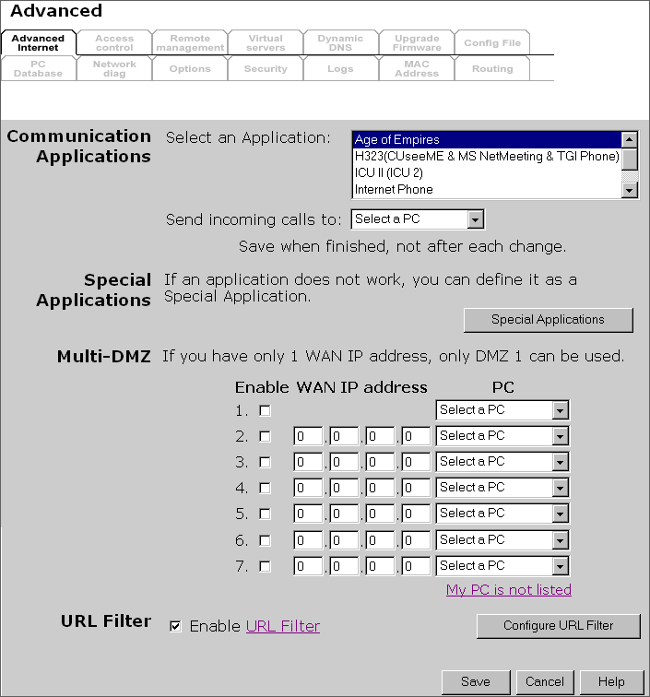

Communication Applications
Most applications are supported transparently by the WL-025. But sometimes it is not clear which PC should receive an incoming connection. This problem could arise with the Communication Applications listed on this screen.
If this problem arises, you can use this screen to set which PC should receive an incoming connection, as described below.
Data - Communication Applications
Select an Application | This lists applications which may generate incoming connections, where the destination PC (on your local LAN) is unknown.
Send incoming calls to | This lists the PCs on your LAN.  - If necessary, you can add PCs manually, using the "PC Database" option on the advanced menu.  - For each application listed above, you can choose a destination PC.  - There is no need to "Save" after each change; you can set the destination PC for each application, then click "Save".

Special Applications
If you use Internet applications which use non-standard connections or port numbers, you may find that they do not function correctly because they are blocked by the WL-025's firewall. In this case, you can define the application as a "Special Application".

Special Applications Screen
This screen can be reached by clicking the Special Applications button on the Internet screen.
You can then define your Special Applications. You will need detailed information about the application; this is normally available from the supplier of the application.
Also, note that the terms "Incoming" and "Outgoing" on this screen refer to traffic from the client (PC) viewpoint
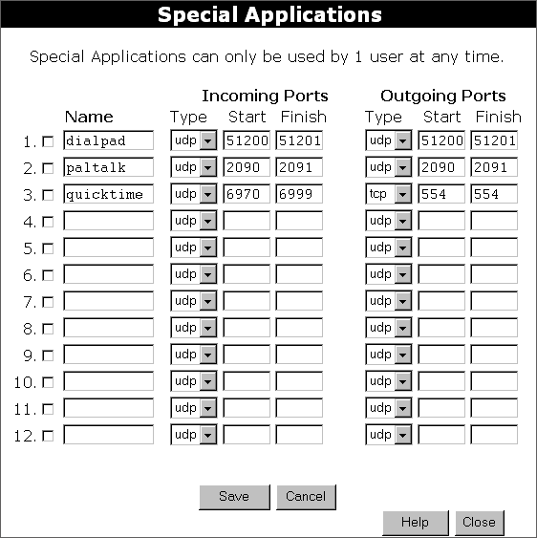

Data - Special Applications Screen
Checkbox | Use this to Enable or Disable this Special Application as required.
Name | Enter a descriptive name to identify this Special Application.
Incoming  Ports | - Type - Select the protocol (TCP or UDP) used when you receive data from the special application or service. (Note: Some applications use different protocols for outgoing and incoming data).  - Start - Enter the beginning of the range of port numbers used by the application server, for data you receive. If the application uses a single port number, enter it in both the "Start" and "Finish" fields.  - Finish - Enter the end of the range of port numbers used by the application server, for data you receive.
Outgoing  Ports | - Type - Select the protocol (TCP or UDP) used when you send data to the remote system or service.  - Start - Enter the beginning of the range of port numbers used by the application server, for data you send to it. If the application uses a single port number, enter it in both the "Start" and "Finish" fields.  - Finish - Enter the end of the range of port numbers used by the application server, for data you send to it. If the application uses a single port number, enter it in both the "Start" and "Finish" fields.

Using a Special Application
- Configure the Special Applications screen as required.
- On your PC, use the application normally. Remember that only one (1) PC can use each Special application at any time. Also, when 1 PC is finished using a particular Special Application, there may need to be a "Time-out" before another PC can use the same Special Application. The "Time-out" period may be up to 3 minutes.

If an application still cannot function correctly, try using the "DMZ" feature.

Multi-DMZ
This feature, if enabled, allows one (1) or more computers on your LAN to be exposed to all users on the Internet.
- If you only have 1 WAN IP addresses, only DMZ 1 can be used. This uses the primary IP address (which may be dynamic), so you do not have to enter it.
- If you have multiple WAN IP addresses, you can specify a DMZ PC for each IP address. You must enter the other WAN IP addresses which are allocated to you.
The DMZ feature allows unrestricted 2-way communication between the "DMZ PC" and other Internet users or Servers.
- This allows almost any application to be used on the "DMZ PC".
- The "DMZ PC" will receive all "Unknown" connections and data sent to the corresponding IP address from the Internet.
- If the DMZ feature is enabled, you must select the PC to be used as the "DMZ PC".

The "DMZ PC" is effectively outside the Firewall, making it more vulnerable to attacks. For this reason, you should only enable the DMZ feature when required.

URL Filter
The URL Filter allows you to block access to undesirable Web site
- To use this feature, you must define "filter strings". If the "filter string" appears in a requested URL, the request is blocked.
- Enabling the URL Filter also affects the Internet Access Log. If Enabled, the "Destination" field in the log will display the URL. Otherwise, it will display the IP Address.
- The URL Filter can be Enabled or Disabled on the Advanced Internet screen.

URL Filter Screen
Click the "Configure URL Filter" button on the Internet screen to access the URL Filter screen. An example screen is shown below.
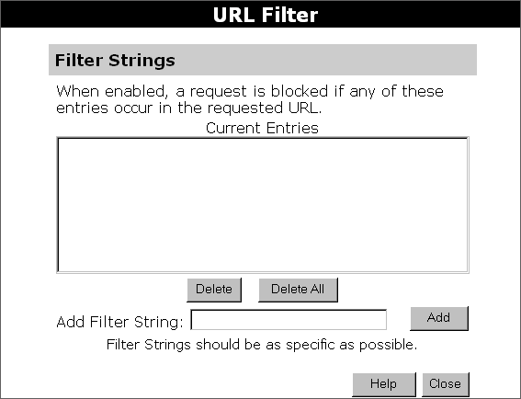

Data - URL Filter Screen
Filter Strings
Current Entries | This lists any existing entries. If you have not entered any values, this list will be empty.
Add Filter String | To add an entry to the list, enter it here, and click the "Add" button.  An entry may be a Domain name (e.g. www.trash.com) or simply a string. (e.g. ads/ )  Any URL which contains ANY entry ANYWHERE in the URL will be blocked.
Buttons
Delete/Delete All | Use these buttons to delete the selected entry or all entries, as required. Multiple entries can be selected by holding down the CTRL key while selecting.(On the Macintosh, hold the SHIFT key while selecting.)
Add | Use this to add the current Filter String to the site list.

Access Control
This feature is accessed by the Access Control link on the Advanced menu.

Overview
The Access Control feature allows administrators to restrict the level of Internet Access available to PCs on your LAN. With the default settings, everyone has unrestricted Internet access.
To use this feature:
- Set the desired restrictions on the "Default" group. All PCs are in the "Default" group unless explicitly moved to another group.
- Set the desired restrictions on the other groups ("Group 1", "Group 2", "Group 3" and "Group 4") as needed.
- Assign PC to the groups as required.

Restrictions are imposed by blocking "Services", or types of connections. All common Services are pre-defined.
If required, you can also define your own Services.

Access Control Screen
To view this screen, select the Access Control link on the Advanced menu.
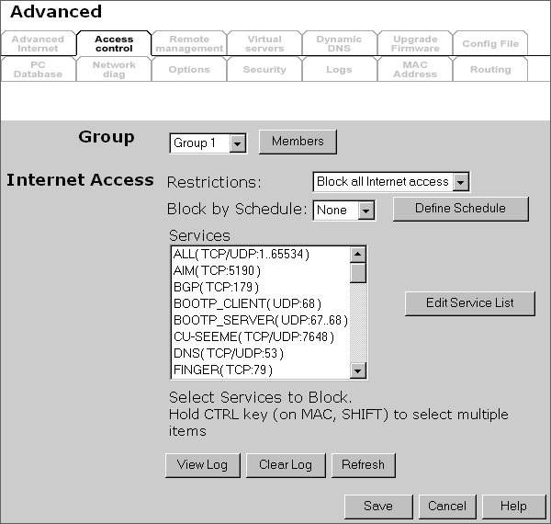

Data - Access Control Screen
Group
Group | Select the desired Group. The screen will update to display the settings for the selected Group. Groups are named "Default", "Group 1", "Group 2", "Group 3" and "Group 4", and cannot be re-named.
"Members" Button | Click this button to add or remove members from the current Group.  - If the current group is "Default", then members can not be added or deleted. This group contains PCs not allocated to any other group.  - To remove PCs from the Default Group, assign them to another Group.  - To assign PCs to the Default Group, delete them from the Group they are currently in.  See the following section for details of the Group Members screen.
Internet Access
Restrictions | Select the desired options for the current group:  - None - Nothing is blocked. Use this to create the least restrictive group.  - Block all Internet access - All traffic via the WAN port is blocked. Use this to create the most restrictive group.  - Block selected Services - You can select which Services are to block. Use this to gain fine control over the Internet access for a group.
Block by Schedule | If Internet access is being blocked, you can choose to apply the blocking only during scheduled times. (If access is not blocked, no Scheduling is possible, and this setting has no effect.)
Define Schedule Button | Clicking this will open a sub-window where you can define or modify the Schedule.
Services | This lists all defined Services. Select the Services you wish to block. To select multiple services, hold the CTRL key while selecting. (On the Macintosh, hold the SHIFT key rather than CTRL.)
Edit Service List Button | If you wish to define additional Services, or manage the Service list, click this button to open the "Services" screen.
Buttons
Members | Click this button to add or remove members from the current Group.  If the current group is "Default", then members can not be added or deleted. This group contains PCs not allocated to any other group.  See the following section for details of the Group Members screen.
Define Schedule | Click this to open a sub-window where you can define or modify the Schedule.
Edit Service List | If you wish to define additional Services, or manage the Service list, click this button to open the "Services" screen.
Save | Save the data on screen.
Cancel | Reverse any changes made since the last "Save".
View Log | Click this to open a sub-window where you can view the "Access Control" log. This log shows attempted Internet accesses which have been blocked by the Access Control feature.
Clear Log | Click this to clear and restart the "Access Control" log, making new entries easier to read.
Refresh | Update the data on screen.

Group Members Screen
This screen is displayed when the Members button on the Access Control screen is clicked.
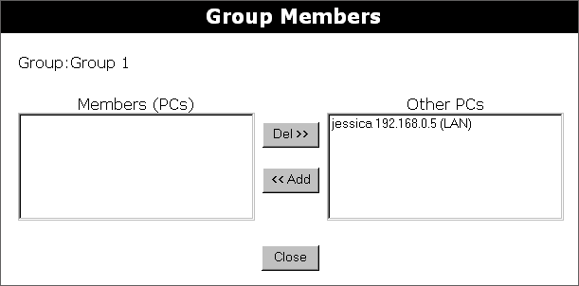
Use this screen to add or remove members (PCs) from the current group.
- The "Del >>" button will remove the selected PC (in the Members list) from the current group.
- The "<< Add" button will add the selected PC (in the Other PCs list) to the current group.

PCs not assigned to any group will be in the "Default" group.
PCs deleted from any other Group will be added to the "Default" group.

Default Schedule Screen
This screen is displayed when the Define Schedule button on the Access Control screen is clicked.
- This schedule can be (optionally) applied to any Access Control Group.
- Blocking will be performed during the scheduled time (between the "Start" and "Finish" times.)
- Two (2) separate sessions or periods can be defined.
- Times must be entered using a 24 hr clock.
- If the time for a particular day is blank, no action will be performed.
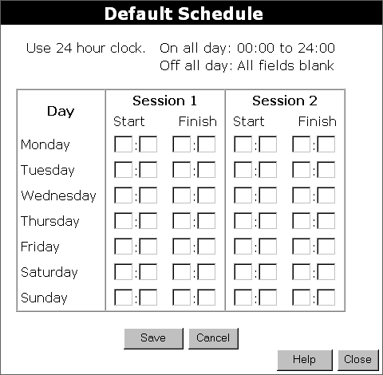

Data - Default Schedule Screen
Day | Each day of the week can scheduled independently.
Session 1  Session 2 | Two (2) separate sessions or periods can be defined. Session 2 can be left blank if not required.
Start | Enter the start using a 24 hr clock.
Finish | Enter the finish time using a 24 hr clock.

Services Screen
This screen is displayed when the Edit Service List button on the Access Control screen is clicked.
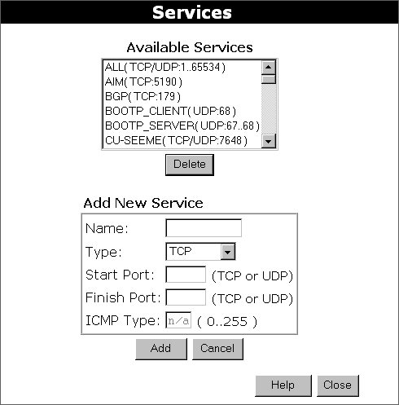

Data - Services Screen
Available Services
Available Services | This lists all the available services.
"Delete" button | Use this to delete any Service you have added. Pre-defined Services can not be deleted.
Add New Service
Name | Enter a descriptive name to identify this service.
Type | Select the protocol (TCP, UDP, ICMP) used to the remote system or service.
Start Port | For TCP and UDP Services, enter the beginning of the range of port numbers used by the service. If the service uses a single port number, enter it in both the "Start" and "Finish" fields.
Finish Port | For TCP and UDP Services, enter the end of the range of port numbers used by the service. If the service uses a single port number, enter it in both the "Start" and "Finish" fields.
ICMP Type | For ICMP Services, enter the type number of the required service.
Buttons
Delete | Delete the selected service from the list.
Add | Add a new entry to the Service list, using the data shown in the "Add New Service" area on screen.
Cancel | Clear the " Add New Service " area, ready for entering data for a new Service.

Access Control Log
To check the operation of the Access Control feature, an Access Control Log is provided. Click the View Log button on the Access Control screen to view this log.
This log shows attempted Internet accesses which have been blocked by the Access Control function.
Data shown in this log is as follows:

Date/Time | Date and Time of the attempted access.
Name | If known, the name of the PC whose access was blocked. This name is taken from the Network Clients database
Source IP address | The IP Address of the PC or device whose access request was blocked
MAC address | The hardware or physical address of the PC or device whose access request was blocked
Destination | The destination URL or IP address

Remote Management
If enabled, this feature allows you to manage the WL-025 via the Internet.
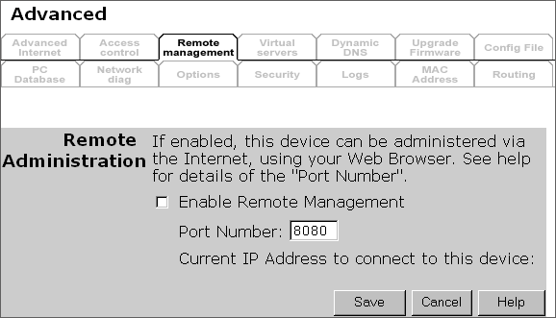
Figure 2: Remote Management Screen

Data - Remote Management Screen
Remote Administration
Enable Remote Management | Enable to allow management via the Internet. If Disabled, this device will ignore management connection attempts from the Internet.
Port Number | Enter a port number between 1024 and 65535 (8080 is recommended). This port number must be specified when you connect (see below).  Note: The default port number for HTTP (Web) connections is port 80, but using port 80 here will prevent the use of a Web "Virtual Server" on your LAN. (See Advanced Internet - Virtual Servers)
Current IP Address | You must use this IP Address to connect (see below).  This IP Address is allocated by your ISP. But if using a Dynamic IP Address, this value can change each time you connect to your ISP. So it is better if your ISP allocates you a Fixed IP Address.

To connect from a remote PC via the Internet
- Ensure your Internet connection is established, and start your Web Browser.
- In the "Address" bar, enter "HTTP://" followed by the Internet IP Address of the WL-025. If the port number is not 80, the port number is also required. (After the IP Address, enter ":" followed by the port number.)
e.g.
HTTP://123.123.123.123:8080
This example assumes the WAN IP Address is 123.123.123.123, and the port number is 8080.

Virtual Servers
This feature, sometimes called "Port Forwarding", allows you to make Servers on your LAN accessible to Internet users. Normally, Internet users would not be able to access a server on your LAN because:
- Your Server does not have a valid external IP Address.
- Attempts to connect to devices on your LAN are blocked by the firewall in this device.
The "Virtual Server" feature solves these problems and allows Internet users to connect to your servers, as illustrated below.
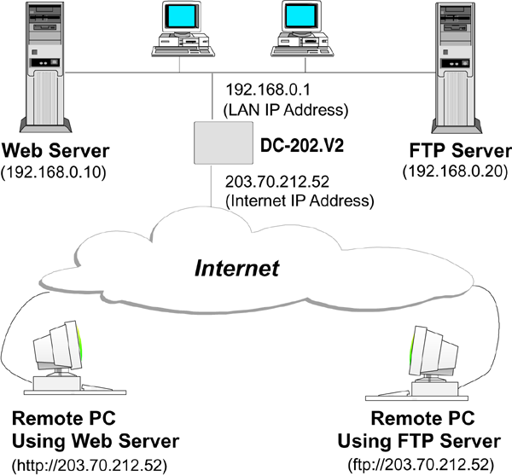

IP Address seen by Internet Users
Note that, in this illustration, both Internet users are connecting to the same IP Address, but using different protocols.
To Internet users, all virtual Servers on your LAN have the same IP Address. This IP Address is allocated by your ISP.
This address should be static, rather than dynamic, to make it easier for Internet users to connect to your Servers.
However, you can use the DDNS (Dynamic DNS) feature to allow users to connect to your Virtual Servers using a URL, instead of an IP Address.

Virtual Servers Screen
The Virtual Servers screen is reached by the Virtual Servers link on the Advanced screen. An example screen is shown below.
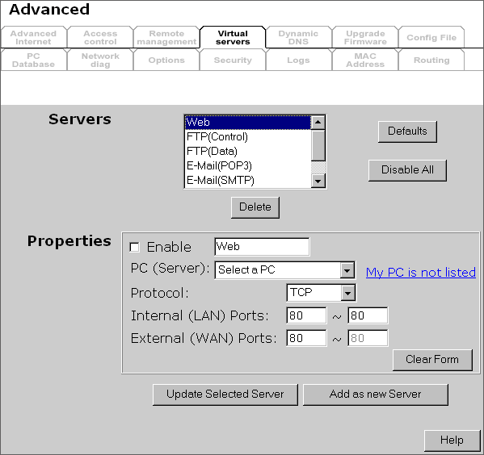

This screen lists a number of pre-defined Servers, and allows you to define your own Servers. Details of the selected Server are shown in the "Properties" area.

Data - Virtual Servers Screen
Servers
Servers | This lists a number of pre-defined Servers, plus any Servers you have defined. Details of the selected Server are shown in the "Properties" area.
Properties
Enable | Use this to Enable or Disable support for this Server, as required.  - If Enabled, any incoming connections will be forwarded to the selected PC.  - If Disabled, any incoming connection attempts will be blocked.
PC (Server) | Select the PC for this Server. The PC must be running the appropriate Server software.
Protocol | Select the protocol (TCP or UDP) used by the Server.
Internal (LAN) Ports | Enter the port number which the Server software is configured to use.
External (WAN) Ports | The port number used by Internet users when connecting to the Server. This is normally the same as the Internal Port Number. If it is different, this device will perform a "mapping" or "translation" function, allowing the server to use one port address, while clients use a different port address.
Buttons
Defaults | This will delete any Servers you have defined, and set the pre-defined Servers to use their default port numbers.
Disable All | This will cause the "Enable" setting of all Virtual Servers to be set OFF.
Update Selected Server | Update the current Virtual Server entry, using the data shown in the "Properties" area on screen.
Add as new Server | Add a new entry to the Virtual Server list, using the data shown in the "Properties" area on screen. The entry selected in the list is ignored, and has no effect.
Delete | Delete the current Virtual Server entry. Note that the pre-defined Servers can not be deleted. Only Servers you have defined yourself can be deleted.
Clear Form | Clear all data from the "Properties" area, ready for input of a new Virtual Server entry.

For each entry, the PC must be running the appropriate Server software.

Defining your own Virtual Servers
If the type of Server you wish to use is not listed on the Virtual Servers screen, you can define and manage your own Servers:
Create a new Server: | - Click "Clear Form"  - Enter the required data, as described above.  - Click "Add".  - The new Server will now appear in the list.
Modify (Edit) a Server: | - Select the desired Server from the list  - Make any desired changes (for example, change the Enable/Disable setting).  - Click "Update" to save changes to the selected Server.
Delete a Server: | - Select the entry from the list.  - Click "Delete".  Note: You can only delete Servers you have defined. Pre-defined Server cannot be deleted.

From the Internet, ALL Virtual Servers have the IP Address allocated by your ISP.

Connecting to the Virtual Servers
Once configured, anyone on the Internet can connect to your Virtual Servers. They must use the Internet IP Address (the IP Address allocated to you by your ISP).
e.g.
http://203.70.212.52
ftp://203.70.212.52
It is more convenient if you are using a Fixed IP Address from your ISP, rather than Dynamic. However, you can use the Dynamic DNS feature, described in the following section, to allow users to connect to your Virtual Servers using a URL, rather than an IP Address.

Dynamic DNS (Domain Name Server)
This free service is very useful when combined with the Virtual Server feature. It allows Internet users to connect to your Virtual Servers using a URL, rather than an IP Address.
This also solves the problem of having a dynamic IP address. With a dynamic IP address, your IP address may change whenever you connect, which makes it difficult to connect to you.
The Service works as follows:
- You must register for the service at http://www.dyndns.org (Registration is free). Your password will be E-mailed to you.
- After registration, use the "Create New Host" option (at www.dyndns.org) to request your desired Domain name.
- Enter your data from www.dyndns.org in the WL-025's DDNS screen.
- The WL-025 will then automatically ensure that your current IP Address is recorded at http://www.dyndns.org
- From the Internet, users will be able to connect to your Virtual Servers (or DMZ PC) using your Domain name, as shown on this screen.

Dynamic DNS Screen
Select Advanced on the main menu, then Dynamic DNS, to see a screen like the following:
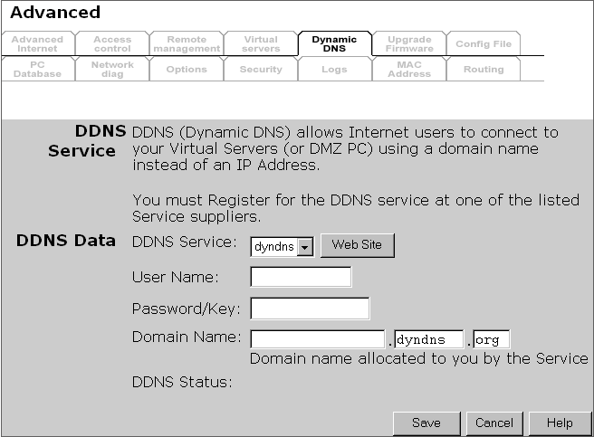

Data - Dynamic DNS Screen
DDNS Service
DDNS Service | - You must register for the service at one of the listed Service Providers. You can reach the Service provider's Web Site by selecting them in the list and clicking the "Web Site" button.  - Apply for a Domain Name, and ensure it is allocated to you.  - Details of your DDNS account (Name, password, Domain name) must then be entered and saved on this screen.  - This device will then automatically ensure that your current IP Address is recorded by the DDNS Service Provider. (You do NOT need to use the "Client" program provided by some DDNS Service providers.)  - From the Internet, users will now be able to connect to your Virtual Servers (or DMZ PC) using your Domain name.
DDNS Data
DDNS Service | Select the desired DDNS Service provider.
User Name | Enter your Username for the DDNS Service.
Password/Key | Enter your current password for the DDNS Service.
Domain Name | Enter the domain name allocated to you by the DDNS Service. If you have more than one name, enter the name you wish to use.
DDNS Status | - This message is returned by the DDNS Server  - Normally, this message should be "Update successful"  - If the message is "No host", this indicates the host name entered was not allocated to you. You need to connect to DDNS Service provider and correct this problem.

Upgrade Firmware
The firmware (software) in the WL-025 can be upgraded using your Web Browser.
You must first download the upgrade file, then select Upgrade on the Advanced menu. You will see a screen like the following.
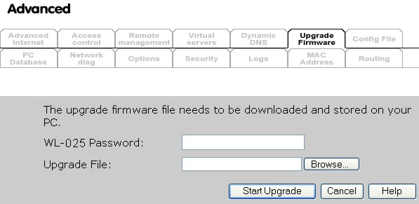

To perform the Firmware Upgrade:
- Click the "Browse" button and navigate to the location of the upgrade file.
- Select the upgrade file. Its name will appear in the Upgrade File field.
- Click the "Start Upgrade" button to commence the firmware upgrade.

The WL-025 is unavailable during the upgrade process, and must restart when the upgrade is completed. Any connections to or through the WL-025 will be lost.

Config File
This feature allows you to download the current settings from the WL-025, and save them to a file on your PC.
You can restore a previously-downloaded configuration file to the WL-025, by uploading it to the WL-025.
This screen also allows you to set the WL-025 back to its factory default configuration. Any existing settings will be deleted.
An example Config File screen is shown below.
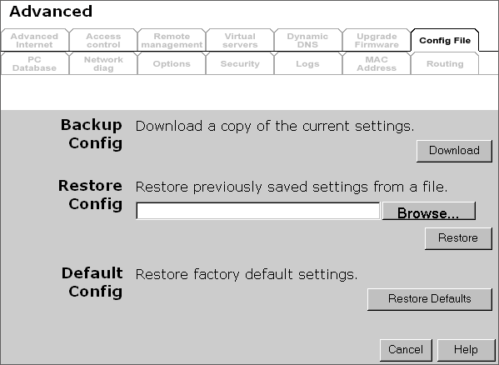

Data - Config File Screen
Backup Config | Use this to download a copy of the current configuration, and store the file on your PC. Click Download to start the download.
Restore Config | This allows you to restore a previously-saved configuration file back to the WL-025.  Click Browse to select the configuration file, then click Restore to upload the configuration file.  WARNING !  Uploading a configuration file will destroy (overwrite) ALL of the existing settings.
Default Config | Clicking the Restore Defaults button will reset the WL-025 to its factory default settings.  WARNING !  This will delete ALL of the existing settings.

PC Database
The PC Database is used whenever you need to select a PC (e.g. for the "DMZ" PC). It eliminates the need to enter IP addresses. Also, you do not need to use fixed IP addresses on your LAN.

PC Database Screen
An example PC Database screen is shown below.
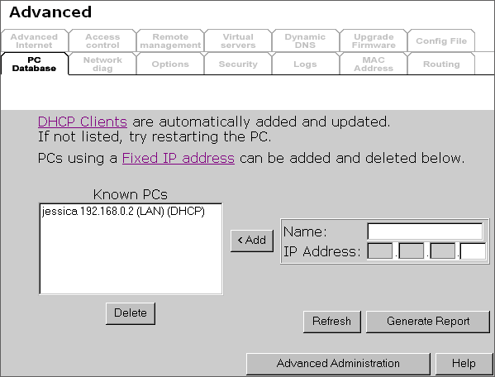

- PCs which are "DHCP Clients" are automatically added to the database, and updated as required.
- By default, non-Server versions of Windows act as "DHCP Clients"; this setting is called "Obtain an IP Address automatically".
- The WL-025 uses the "Hardware Address" to identify each PC, not the name or IP address. The "Hardware Address" can only change if you change the PC's network card or adapter.
- This system means you do NOT need to use Fixed (static) IP addresses on your LAN. However, you can add PCs using Fixed (static) IP Addresses to the PC database if required.

Data - PC Database Screen
Known PCs | This lists all current entries. Data displayed is name (IP Address) type. The "type" indicates whether the PC is connected to the LAN.
Name | If adding a new PC to the list, enter its name here. It is best if this matches the PC's "hostname".
IP Address | Enter the IP Address of the PC. The PC will be sent a "ping" to determine its hardware address. If the PC is not available (not connected, or not powered On) you will not be able to add it.
Buttons
Add | This will add the new PC to the list. The PC will be sent a "ping" to determine its hardware address. If the PC is not available (not connected, or not powered On) you will not be able to add it.
Delete | Delete the selected PC from the list. This should be done in 2 situations:  - The PC has been removed from your LAN.  - The entry is incorrect.
Refresh | Update the data on screen.
Generate Report | Display a read-only list showing full details of all entries in the PC database.
Advanced  Administration | View the Advanced version of the PC database screen - PC Database (Admin). See below for details.

PC Database (Admin)
This screen is displayed if the "Advanced Administration" button on the PC Database is clicked. It provides more control than the standard PC Database screen.
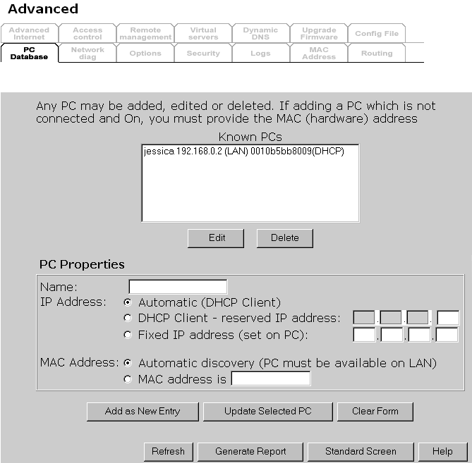

Data - PC Database ( Admin) Screen
Known PCs | This lists all current entries. Data displayed is name (IP Address) type. The "type" indicates whether the PC is connected to the LAN.
PC Properties
Name | If adding a new PC to the list, enter its name here. It is best if this matches the PC's "hostname".
IP Address | Select the appropriate option:  - Automatic - The PC is set to be a DHCP client (Windows: "Obtain an IP address automatically"). The WL-025 will allocate an IP address to this PC when requested to do so. The IP address could change, but normally won't.  - DCHP Client - Reserved IP Address - Select this if the PC is set to be a DCHP client, and you wish to guarantee that the WL-025 will always allocate the same IP Address to this PC.  Enter the required IP address. Only the last field is required; the other fields must match the WL-025's IP address.  - Fixed IP Address - Select this if the PC is using a Fixed (Static) IP address. Enter the IP address allocated to the PC. (The PC must be configured to use this IP address.)
MAC Address | Select the appropriate option  - Automatic discovery - Select this to have the WL-025 contact the PC and find its MAC address. This is only possible if the PC is connected to the LAN and powered On.  - MAC is - Enter the MAC address on the PC. The MAC address is also called the "Hardware Address", "Physical Address", or "Network Adapter Address". The WL-025 uses this to provide a unique identifier for each PC. Because of this, the MAC address can NOT be left blank.
Buttons
Add as New Entry | Add a new PC to the list, using the data in the "Properties" box.  If "Automatic discovery" (for MAC address) is selected, the PC will be sent a "ping" to determine its hardware address. This will fail unless the PC is connected to the LAN, and powered on.
Update Selected PC | Update (modify) the selected PC, using the data in the "Properties" box.
Clear Form | Clear the "Properties" box, ready for entering data for a new PC.
Refresh | Update the data on screen.
Generate Report | Display a read-only list showing full details of all entries in the PC database.
Standard Screen | Click this to view the standard PC Database screen.

Network Diagnostics
This screen allows you to perform a "Ping" or a DNS lookup. These activities can be useful in solving network problems. An example Network Diagnostics screen is shown below.
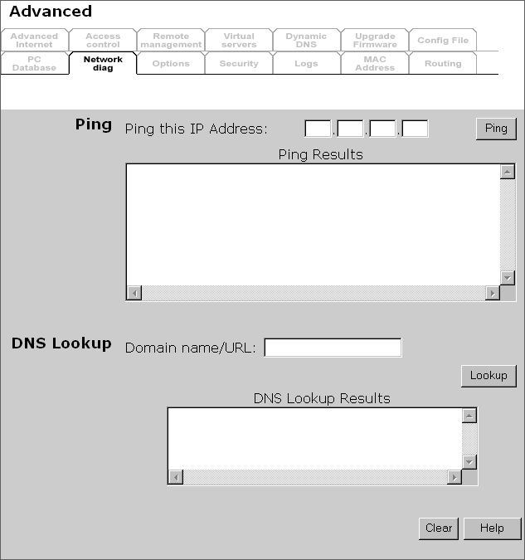

Data - Network Diagnostics Screen
Ping
Ping this  IP Address | Enter the IP address you wish to ping. The IP address can be on your LAN, or on the Internet. Note that if the address is on the Internet, and no connection currently exists, you could get a "Timeout" error. In that case, wait a few seconds and try again.
Ping Button | After entering the IP address, click this button to start the "Ping" procedure. The results will be displayed in the Ping Results pane.
DNS Lookup
Domain name/URL | Enter the Domain name or URL for which you want a DNS (Domain Name Server) lookup. Note that if the address in on the Internet, and no connection currently exists, you could get a "Timeout" error. In that case, wait a few seconds and try again.
Lookup Button | After entering the Domain name/URL, click this button to start the "DNS Lookup" procedure.

Options
This screen allows advanced users to enter or change a number of settings. For normal operation, there is no need to use this screen or change any settings.
An example Options screen is shown below.
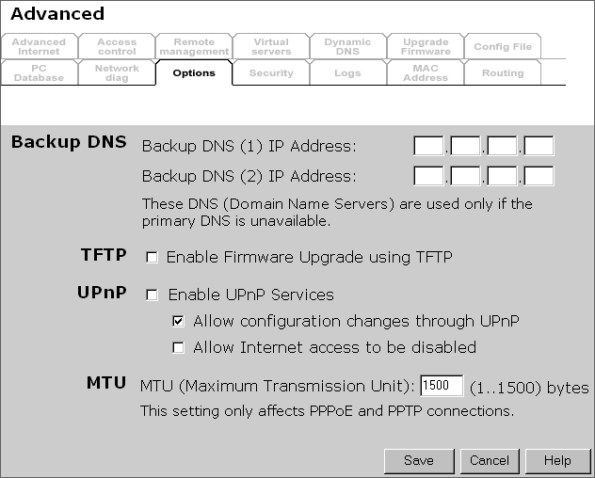

Data - Options Screen
Backup DNS
IP Address | Enter the IP Address of the DNS (Domain Name Servers) here. These DNS will be used only if the primary DNS is unavailable.
TFTP
Enable Firmware Upgrade using TFTP | - If enabled, TFTP (Trivial FTP) can be used to upgrade the firmware in this device. This is normally not required; a Windows utility is available for this purpose.  - You must obtain the firmware upgrade file first; instructions for using TFTP will be available with the upgrade.
UpnP
Enable UPnP  Services | - UPnP (Universal Plug and Play) allows automatic discovery and configuration of equipment attached to your LAN. UPnP is by supported by Windows ME, XP, or later.  - If Enabled, this device will be visible via UPnP.  - If Disabled, this device will not be visible via UPnP.
Allow Configuration... | - If checked, then UPnP users can change the configuration.  - If Disabled, UPnP users can only view the configuration. But currently, this restriction only applies to users running Windows XP, who access the Properties via UPnP. (e.g. Right - click the WL-025 in My Network Places, and select Properties)
Allow Internet access to be disabled | - If checked, then UPnP users can disable Internet access via this device.  - If Disabled, UPnP users can NOT disable Internet access via this device. But currently, this restriction only applies to users running Windows XP, who access the Properties via UPnP. (e.g. Right - click the WL-025 in My Network Places, and select Properties)
MTU
MTU size | MTU (Maximum Transmission Unit) value should only be changed if advised to do so by Technical Support.  - Enter a value between 1 and 1500.  - This device will still auto-negotiate with the remote server, to set the MTU size. The smaller of the 2 values (auto-negotiated, or entered here) will be used.  - For direct connections (not PPPoE or PPTP), the MTU used is always 1500.

Security
This screen allows you to set Firewall and other security-related options.
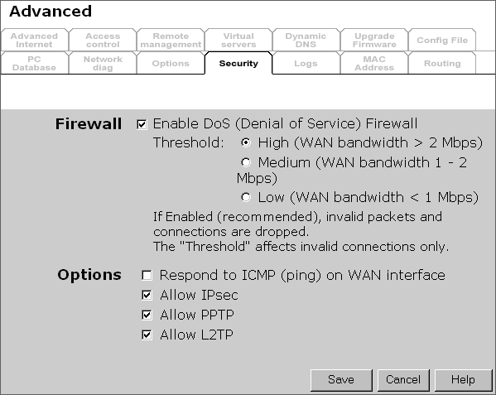

Data - Security Screen
Firewall
Enable DoS  Firewall | If enabled, DoS (Denial of Service) attacks will be detected and blocked. The default is enabled. It is strongly recommended that this setting be left enabled.  Note:  - A DoS attack does not attempt to steal data or damage your PCs, but overloads your Internet connection so you can not use it - the service is unavailable.  - This device uses "Stateful Inspection" technology. This system can detect situations where individual TCP/IP packets are valid, but collectively they become a DoS attack.
Threshold | This setting affects the number of "half-open" connections allowed.  - A "half-open" connection arises when a remote client contacts the Server with a connection request, but then does not reply to the Server's response.  - While the optimum number of "half-open" connections allowed (the "Threshold") depends on many factors, the most important factor is the available bandwidth of your Internet connection.  - Select the setting to match the bandwidth of your Internet connection.
Options
Respond to ICMP | The ICMP protocol is used by the "ping" and "traceroute" programs, and by network monitoring and diagnostic programs.  - If checked, the WL-025 will repond to ICMP packets received from the Internet.  - If not checked, ICMP packets from the Internet will be ignored. Disabling this option provides a slight increase in security.
Allow IPsec | The IPSec protocol is used to establish a secure connection, and is widely used by VPN (Virtual Private Networking) programs.  - If checked, IPSec connections are allowed.  - If not checked, IPSec connections are blocked.
Allow PPTP | PPTP (Point to Point Tunneling Protocol) is widely used by VPN (Virtual Private Networking) programs.  - If checked, PPTP connections are allowed.  - If not checked, PPTP connections are blocked.
Allow L2TP | L2TP is a protocol developed by Cisco for VPNs (Virtual Private Networks).  - If checked, L2TP connections are allowed.  - If not checked, L2TP connections are blocked.

Logs
The Logs record various types of activity on the WL-025. This data is useful for troubleshooting, but enabling all logs will generate a large amount of data and adversely affect performance.
Since only a limited amount of log data can be stored in the WL-025, log data can also be E-mailed to your PC.
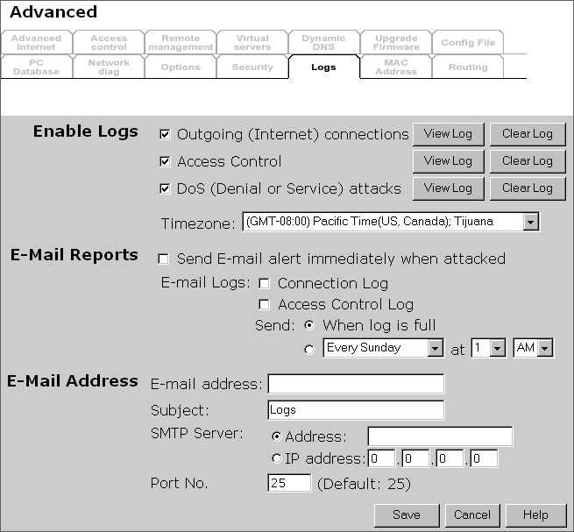

Data - Logs Screen
Enable Logs
Outgoing Connections | If selected, Outgoing Internet connections are logged. Normally, the (Internet) "Destination" will be shown as an IP address. But if the "URL Filter" is enabled, the "Destination" will be shown as a URL.
Access Control | If enabled, the log will include attempted outgoing connections which have been blocked by the "Access Control" feature.
DoS Attacks | If enabled, this log will show details of DoS (Denial of Service) attacks which have been blocked by the built-in Firewall.
Timezone | Select the correct Timezone for your location. This is required for the date/time shown on the logs to be correct.
E-Mail Reports
Send E-mail alert | If enabled, an E-mail will be sent immediately if a DoS (Denial of Service) attack is detected. If enabled, the E-mail address information must be provided.
E-mail Logs | You can choose to have the logs E-mailed to you, by enabling either or both checkboxes. If enabled, the Log will be sent to the specified E-mail address. The interval between E-mails is determined by the "Send" setting.
Send | Select the desired option for sending the log by E-mail.  - When log is full - The time is not fixed. The log will be sent when the log is full, which will depend on the volume of traffic.  - Every day, Every Monday ... - The log is sent on the interval specified.  - If "Every day" is selected, the log is sent at the time specified.  - If the day is specified, the log is sent once per week, on the specified day.  - Select the time of day you wish the E-mail to be sent.  - If the log is full before the time specified to send it, it will be sent regardless.
E-Mail Address
E-mail Address | Enter the E-mail address the Log is to be sent to. The E-mail will also show this address as the Sender's address.
Subject | Enter the text string to be shown in the "Subject" field for the E-mail.
SMTP Server | Enter the address or IP address of the SMTP (Simple Mail Transport Protocol) Server you use for outgoing E-mail.
Port No. | Enter the port number used to connect to the SMTP Server. The default value is 25.

MAC Address
The MAC (hardware) address is a low-level network identifier. It may be called "MAC Address", "Hardware Address", or "Physical Address". On a PC, this address is associated with the Network card or adapter. The address on the MAC Address screen is the address on the Internet (WAN port) interface, and has no effect on the LAN interface.
- If your ISP asks for the Network Adapter Address, Physical Address, Hardware Address, or MAC Address for the PC the DSL/Cable modem is connected to, provide this value.
- If your ISP has already recorded a MAC Address, you can change the address used by the WL-025 to match the address recorded by your ISP.

MAC Address Screen
Select MAC Address from the Advanced menu to reach a screen like the example below.
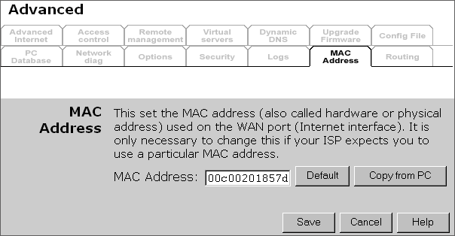

Data - MAC Address Screen
MACAddress | The current MAC (hardware) address is displayed.  If your ISP has recorded a Hardware Address, you can "spoof" that address by entering it in the address field. The hardware address consists of 12 characters, where each character is a digit (0..9) or a character between A and F.
Buttons
Default | Inserts the default MAC address into the MAC address field. You must click "Save" to actually change the address used.
Copy from PC | Inserts the MAC address from your PC into the MAC address field. You must click "Save" to actually change the address used.
Save | Save your changes to the WL-025.
Cancel | Reverse any changes made since the last "Save".

If the MAC address is changed, the WL-025 must restart.

Routing

Overview
- If you don't have other Routers or Gateways on your LAN, you can ignore the "Routing" page completely.
- If the WL-025 is only acting as a Gateway for the local LAN segment, ignore the "Routing" page even if your LAN has other Routers.
- If your LAN has a standard Router (e.g. Cisco) on your LAN, and the WL-025 is to act as a Gateway for all LAN segments, enable RIP (Routing Information Protocol) and ignore the Static Routing table.
- If your LAN has other Gateways and Routers, and you wish to control which LAN segments use each Gateway, do NOT enable RIP (Routing Information Protocol). Configure the Static Routing table instead. (You also need to configure the other Routers.)
- If using Windows 2000 Data center Server as a software Router, enable RIP on the WL-025, and ensure the following Windows 2000 settings are correct:
- Open Routing and Remote Access
- In the console tree, select Routing and Remote Access , [server name], IP Routing, RIP
- In the "Details" pane, right-click the interface you want to configure for RIP version 2, and then click "Properties".
- On the "General" tab, set Outgoing packet protocol to "RIP version 2 broadcast", and Incoming packet protocol to "RIP version 1 and 2".

Routing Screen
The routing table is accessed by the Routing link on the Administration menu.

Using this Screen
Generally, you will use either RIP (Routing Information Protocol) OR the Static Routing Table, as explained above, although is it possible to use both methods simultaneously.
Static Routing Table
- If RIP is not used, an entry in the routing table is required for each LAN segment on your Network, other than the segment to which this device is attached.
- The other Routers must also be configured. See Configuring Other Routers on your LAN later in this chapter for further details and an example.

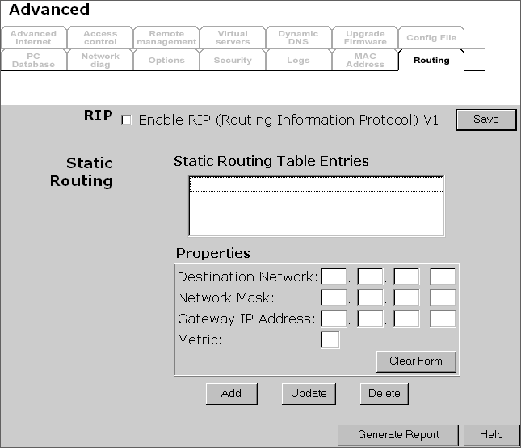

Data - Routing Screen
RIP
Enable RIP | Check this to enable the RIP (Routing Information Protocol) feature of the WL-025.  The WL-025 supports RIP 1 only.
Static Routing
Static Routing  Table Entries | This list shows all entries in the Routing Table.  - The "Properties" area shows details of the selected item in the list.  - Change any the properties as required, then click the "Update" button to save the changes to the selected entry.
Properties | - Destination Network - The network address of the remote LAN segment. For standard class "C" LANs, the network address is the first 3 fields of the Destination IP Address. The 4th (last) field can be left at 0.  - Network Mask - The Network Mask for the remote LAN segment. For class "C" networks, the default mask is 255.255.255.0  - Gateway IP Address - The IP Address of the Gateway or Router which the WL-025 must use to communicate with the destination above. (NOT the router attached to the remote segment.)  - Metric - The number of "hops" (routers) to pass through to reach the remote LAN segment. The shortest path will be used. The default value is 1.
Buttons
Save | Save the RIP setting. This has no effect on the Static Routing Table.
Add | Add a new entry to the Static Routing table, using the data shown in the "Properties" area on screen. The entry selected in the list is ignored, and has no effect.
Update | Update the current Static Routing Table entry, using the data shown in the "Properties" area on screen.
Delete | Delete the current Static Routing Table entry.
Clear Form | Clear all data from the "Properties" area, ready for input of a new entry for the Static Routing table.
Generate Report | Generate a read-only list of all entries in the Static Routing table.

Configuring Other Routers on your LAN
It is essential that all IP packets for devices not on the local LAN be passed to the WL-025, so that they can be forwarded to the external LAN, WAN, or Internet. To achieve this, the local LAN must be configured to use the WL-025 as the Default Route or Default Gateway.

Local Router
The local router is the Router installed on the same LAN segment as the WL-025. This router requires that the Default Route is the WL-025 itself. Typically, routers have a special entry for the Default Route. It should be configured as follows.
Destination IP Address | Normally 0.0.0.0, but check your router documentation.
Network Mask | Normally 0.0.0.0, but check your router documentation.
Gateway IP Address | The IP Address of the WL-025.
Metric | 1

Other Routers on the Local LAN
Other routers on the local LAN must use the WL-025's Local Router as the Default Route. The entries will be the same as the WL-025's local router, with the exception of the Gateway IP Address.
- For a router with a direct connection to the WL-025's local Router, the Gateway IP Address is the address of the WL-025's local router.
- For routers which must forward packets to another router before reaching the WL-025's local router, the Gateway IP Address is the address of the intermediate router.

Static Routing - Example
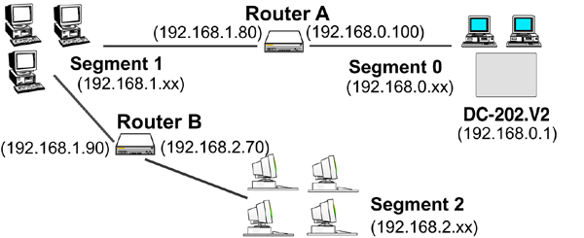

For the WL-025's Routing Table
For the LAN shown above, with 2 routers and 3 LAN segments, the WL-025 requires 2 entries as follows.
Entry 1 (Segment 1)
Destination IP Address | 192.168.1.0
Network Mask | 255.255.255.0 (Standard Class C)
Gateway IP Address | 192.168.0.100 (WL-025's local Router)
Metric | 2
Entry 2 (Segment 2)
Destination IP Address | 192.168.2.0
Network Mask | 255.255.255.0 (Standard Class C)
Gateway IP Address | 192.168.0.100
Metric | 3

For Router A's Default Route
Destination IP Address | 0.0.0.0
Network Mask | 0.0.0.0
Gateway IP Address | 192.168.0.1 (WL-025's IP Address)

For Router B's Default Route
Destination IP Address | 0.0.0.0
Network Mask | 0.0.0.0
Gateway IP Address | 192.168.1.80 (WL-025's local router)

Appendix A
Troubleshooting

Overview
This chapter covers some common problems that may be encountered while using the WL-025 and some possible solutions to them. If you follow the suggested steps and the WL-025 still does not function properly, contact your dealer for further advice.

General Problems
Problem 1: | Can't connect to the WL-025 to configure it.
Solution 1: | Check the following:  - The WL-025 is properly installed, LAN connections are OK, and it is powered ON.  - Ensure that your PC and the WL-025 are on the same network segment. (If you don't have a router, this must be the case.)  - If your PC is set to "Obtain an IP Address automatically" (DHCP client), restart it.  - If your PC uses a Fixed (Static) IP address, ensure that it is using an IP Address within the range 192.168.0.2 to 192.168.0.254 and thus compatible with the WL-025's default IP Address of 192.168.0.1.  Also, the Network Mask should be set to 255.255.255.0 to match the WL-025.  In Windows, you can check these settings by using Control Panel-Network to check the Properties for the TCP/IP protocol.

Internet Access
Problem 1: | When I enter a URL or IP address I get a time out error.
Solution 1: | A number of things could be causing this. Try the following troubleshooting steps.  - Check if other PCs work. If they do, ensure that your PCs IP settings are correct. If using a Fixed (Static) IP Address, check the Network Mask, Default gateway and DNS as well as the IP Address.  - If the PCs are configured correctly, but still not working, check the WL-025. Ensure that it is connected and ON. Connect to it and check its settings. (If you can't connect to it, check the LAN and power connections.)  - If the WL-025 is configured correctly, check your Internet connection (DSL/Cable modem etc) to see that it is working correctly.
Problem 2: | Some applications do not run properly when using the WL-025.
Solution 2: | The WL-025 processes the data passing through it, so it is not transparent.  Use the Special Applications feature to allow the use of Internet applications which do not function correctly.  If this does solve the problem you can use the DMZ function. This should work with almost every application, but:  - It is a security risk, since the firewall is disabled.  - Only one (1) PC can use this feature.

Wireless Access
Problem 1: | My PC can't locate the Wireless Access Point.
Solution 1: | Check the following.  - Your PC is set to Infrastructure Mode. (Access Points are always in Infrastructure Mode)  - The SSID on your PC and the Wireless Access Point are the same.  Remember that the SSID is case-sensitive. So, for example "Workgroup" does NOT match "workgroup".  - Both your PC and the Wireless Access Point must have the same setting for WEP. The default setting for the WL-025 is disabled, so your wireless station should also have WEP disabled.  - If WEP is enabled on the WL-025, your PC must have WEP enabled, and the key must match.  - If using 256 Bit WEP keys, then only compatible devices using the TI chipset will be able to connect.  - If the WL-025's Wireless screen is set to Allow LAN access to selected Wireless Stations only, then each of your Wireless stations must have been selected, or access will be blocked.  - To see if radio interference is causing a problem, see if connection is possible when close to the Wireless Access Point.  Remember that the connection range can be as little as 100 feet in poor environments.
Problem 2: | Wireless connection speed is very slow.
Solution 2: | The wireless system will connect at the highest possible speed, depending on the distance and the environment. To obtain the highest possible connection speed, you can experiment with the following:  - Access Point location.  Try adjusting the location and orientation of the Access Point.  - Wireless Channel  If interference is the problem, changing to another channel may show a marked improvement.  - Radio Interference  Other devices may be causing interference. You can experiment by switching other devices Off, and see if this helps. Any "noisy" devices should be shielded or relocated.  - RF Shielding  Your environment may tend to block transmission between the wireless stations. This will mean high access speed is only possible when close to the Access Point.

Appendix B
Specifications

Wireless Network Broadband Router
Model | WL-025
Dimensions | 187mm(W) * 128mm(D) * 30mm(H)
Operating Temperature | 0° C to 40° C
Storage Temperature | -10° C to 70° C
Network Protocol: | TCP/IP
Network Interface: | 5 Ethernet:  4 * 10/100BaseT (RJ45) LAN connection  1 * 10/100BaseT (RJ45) for WAN
LEDs | 12
Power Adapter | 12 V DC External

Wireless Interface
Standards | IEEE802.11b WLAN, PCMCIA 2.1, JEIDA 4.2, roaming support  TI "B+" 22Mbps support
Frequency | 2.4 to 2.4835GHz ( Industrial Scientific Medical Band )
Channels | Maximum 14 Channels, depending on regulatory authorities
Modulation | DSSS BPSK/QPSK/CC
Data Rate | 11 / 5.5 / 2 / 1 Mbps
Coverage Area | Indoors : 25m @11Mbps, 100m @5.5Mbps or lower  Outdoors : 150m @11Mbps, 250m @5.5Mbps or lower
WEP | 64Bit, 128Bit, 256Bit
Output Power | 13dBm (typical)
Receiver Sensitivity | -80dBm Min.

FCC Statement
This equipment has been tested and found to comply with the limits for a Class B digital device, pursuant to Part 15 of the FCC Rules. These limits are designed to provide reasonable protection against harmful interference in a residential installation.
This equipment generates, uses and can radiate radio frequency energy and, if not installed and used in accordance with the instructions, may cause harmful interference to radio communications. However, there is no guarantee that interference will not occur in a particular installation. If this equipment does cause harmful interference to radio or television reception, which can be determined by turning the equipment off and on, the user is encouraged to try to correct the interference by one of the following measures:
- Reorient or relocate the receiving antenna.
- Increase the separation between the equipment and receiver.
- Connect the equipment into an outlet on a circuit different from that to which the receiver is connected.
- Consult the dealer or an experienced radio/TV technician for help.
To assure continued compliance, any changes or modifications not expressly approved by the party responsible for compliance could void the user's authority to operate this equipment. (Example - use only shielded interface cables when connecting to computer or peripheral devices).

FCC Radiation Exposure Statement
This equipment complies with FCC RF radiation exposure limits set forth for an uncontrolled environment. This equipment should be installed and operated with a minimum distance of 20 centimeters between the radiator and your body.
This device complies with Part 15 of the FCC Rules. Operation is subject to the following two conditions:
(1) This device may not cause harmful interference, and
(2) This device must accept any interference received, including interference that may cause undesired operation.
This transmitter must not be co-located or operating in conjunction with any other antenna or transmitter.

CE Marking Warning
This is a Class B product. In a domestic environment this product may cause radio interference in which case the user may be required to take adequate measures.

