MOSFET simple

I propose you here a basic MOSFET amplifier. Output power is +/- 100 Wrms under 8 ohms or +/- 160 Wrms under 4 ohms.
Due to the circuit simplicity, distortion is +/- 0.1 %. Bandwidth at -3 db is from 4 Hz to 96 Khz, it is limited by C1, R1, C2 and R2.
Transistors T1 and T2 makes a first differential stage, current source of +/- 1 mA is set by R3. In the upgraded version, current source is more efficient in stability. P1 allows a fine tuning of DC voltage at amplifier's output. Place P1 at it's half value for first power up, then turn it slowly for a lowest DC output voltage. Use a first quality compoment.
Input sensitivity is 1.2 volts. The gain of 27x is archived by R7/R6. It may be modified by changing R7 value.
Transistors T5 and T6 makes the second differential stage. Transistors T3 and T4 warks as a current mirror source. They push the second differential stage to drain equal current. Doing so we get a high gain and an excellent linearity.
Output MOSFET transistors works in AB class, their quiescient current is set from 50 to 100 mA trough P2.
For setting quiescient current, you must set P2 in minimal resistance, place a multimeter in mV DC range accross on R14 or R15 leads, turn slowly the screw untill you read a 16,5 mV value, which correspond to a 50 mA quiescient current.
F1 and F2 works as an elementary output short-circuit protection.
The power supply must have a value between 45 and 55 Volts DC (positive and negative).
One heatsink with a thermal resistance less of 2° C / W is required.
All resistors are 1% metal film 1/4 watt.
Before connecting a speaker at amplifier output, connect a multimeter at output and look on DC output voltage. This level never may be greater than 50 mV. If it is so, check all amplifier for a mistake. Also, change T2 with another device and check again.

This amplifier is very simple to build and low cost. It fits perfectly for Hi-Fi use, a bass bin, an instrument amplifier (guitar, keyboard...).

Diagram

Basic version

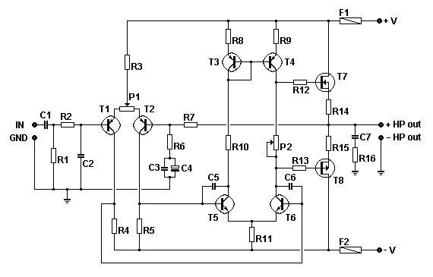

Upgraded version - modified compoments are labelled in blue
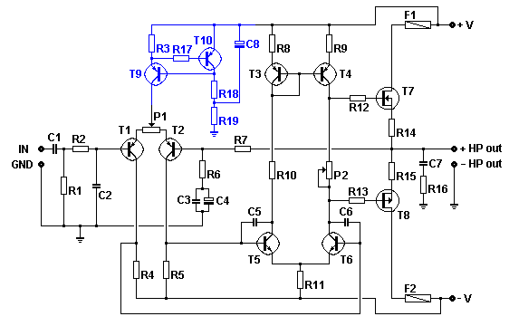
PCB proposal

Basic version

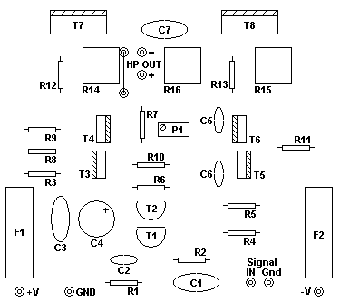
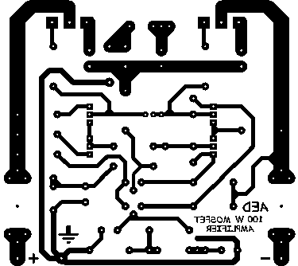

Upgraded version

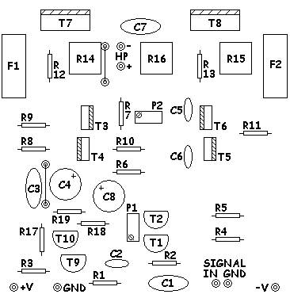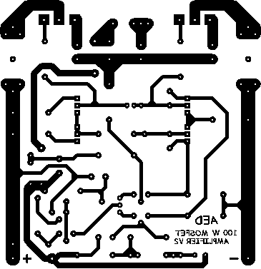

Compoment values

C1 = 2,2 µF MKP, MKT 100 V
C2 = 330 pF céramique 50 V
C3 = 100 nF MKP, MKT 100 V
C4 = 100 µF 40 V électro-chimique
C5, C6 = 18 pF céramique 50 V
C7 = 100 nF MKP, MKT 250 V (C8 = 47 µF 100 V)
R1, R3 = 47 K (R3 = 330 -> 470 Ohms)
R2 = 2K2
R4, R5 = 3K9
R6 = 1 K
R7 = 27 K
R8, R9, R11 = 100 ohms
R10 = 10 K
R12, R13 = 470 ohms
R14, R15 = 0.33 ohms 5 watts
R16 = 10 ohms 3 watts (R17 = 1 K R18, R19 = 10K)
T1, T2, T9,T10 = 2N5401, ZTX558, BC556B (attention au brochage différent - take care for pin layout)
T3, T4 = BF470, MJE350, 2SB649
T5, T6 = BF469, MJE340, 2SD669
T7 = IRFP240, 2SK1530, 2SJ162, BUZ900DP, BUZ901DP (attention au brochage différent - take care for pin layout : GDS GSD)
T8 = IRFP9240, 2SJ201, 2SK1058, BUZ905DP, BUZ906DP (attention au brochage différent - take care for pin layout : GDS GSD)
P1 = 100 ohms (25 tours - 25 turns)
P2 = 2K5 (25 tours - 25 turns)
F1, F2 = 3 A T

Alimentation type / typical power supply
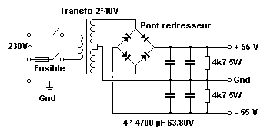
One 2x40 volts 225 VA transformer is exactly what we need for one mono amplifier.
For a stereo amplifier, one 2x40 volts 500 VA transformer is required.
Use at least 4x4700 µF 63/80 V reservoir capacitors. How more caps you use, how better it is for ripple rejection.
4K7 5W resistors are used to discharge reservoir capacitors once mains is set off.

For a good amplifier working, you must use a DC protection circuit and a delayed speaker on. I propose such a circuit in my projects. You also may use the kit number K4700 from Velleman. Web site = www.velleman.be

Caracteristics

power : 100 wrms 8 ohms - 160 wrms 4 ohms
bandwidth : 4 Hz - 96 Khz (-3db)
signal noise level : -90 db
distortion : 0.1 %
input level : 1.2 volts
power supply : +45 -> +55 V and -45 -> -55 V
damping factor : > 200

Download area

Clic here for going to the amplifier PCB, basic version. 600 DPI (55.6 Ko).

Clic here for going to the amplifier PCB, upgraded version. 600 DPI (59 Ko).

Clic here for going to the amplifier power supply PCB. 600 DPI (20 Ko).
